## 实验四：数据查询与修改实验

### 5.1 Basic structure of SQL Queries

5.1.1 Query on a A Single Relation---The select, where Clause

根据路测ATU数据表，使用distinct语句列出服务小区频点为38400的所有去重后的服务小区ID。

select distinct CellID from tbATUData where EARFCN = 38400

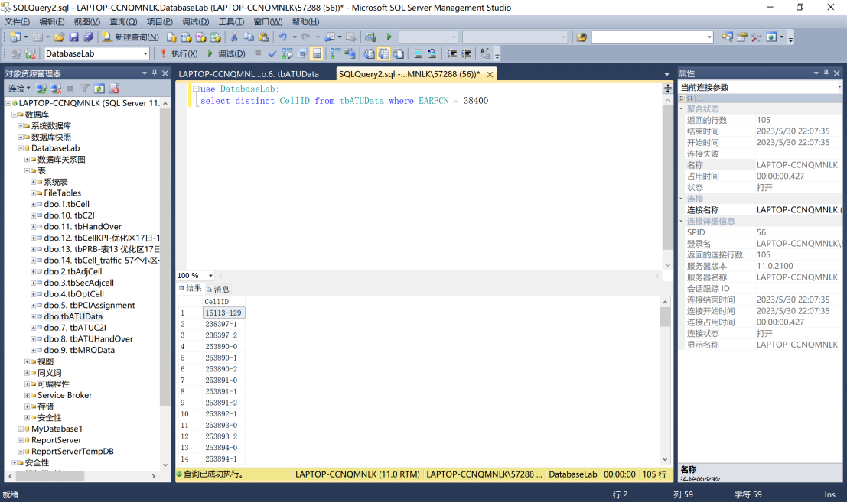

5.1.2 Query on multiple relations——The from Clause

根据路测ATU C2I干扰矩阵表和路测ATU切换统计矩阵表，查询主小区ID为“238397-1”的小区的同站干扰小区ID和切换目标小区ID。

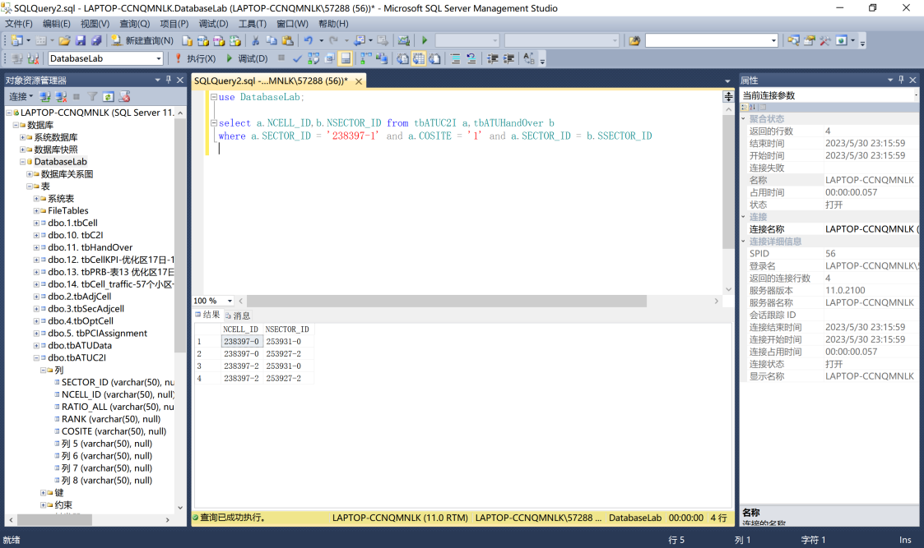

5.1.3 natural join

使用nature join语句重写1.2中的查询。

SELECT NCELL_ID,NSECTOR_ID

FROM tbatuc2i join tbatuhandover

on SECTOR_ID='238397-1' and SSECTOR_ID = '238397-1' and COSITE = 1

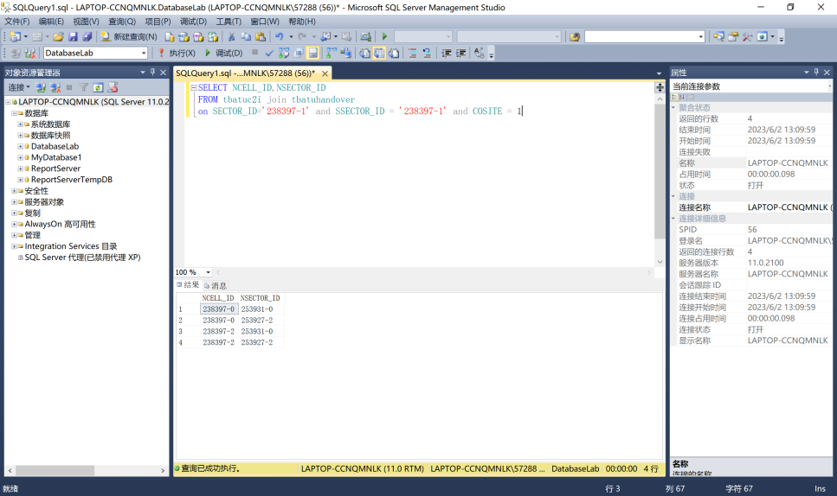

5.2 Additional Basic Operations

5.2.1 The Rename Operation

根据基于MR测量报告的干扰分析表，使用as语句查询所有比主小区ID为“124673-0”，邻小区ID为“259772-0”的小区间C2I干扰均值高的主小区ID、邻小区ID。

select a.SCELL,a.NCELL

from tbc2i as a,tbc2i as b

where a.C2I_Mean > b.C2I_Mean and b.SCELL = '124673-0' and b.NCELL = '259772-0'

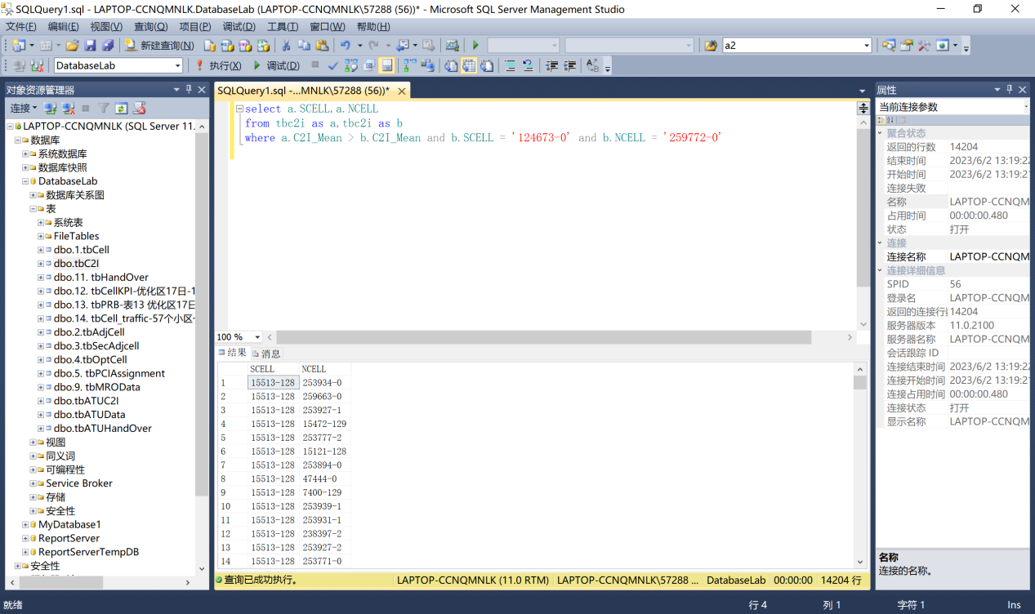

5.2.2 String Operations & 5.2.3 Attribute Specification

根据小区PCI优化调整结果表，使用like语句查询小区名中包含“B马”的相关信息。

select * from tbPCIAssignment where SECTOR_NAME like '%B马%'

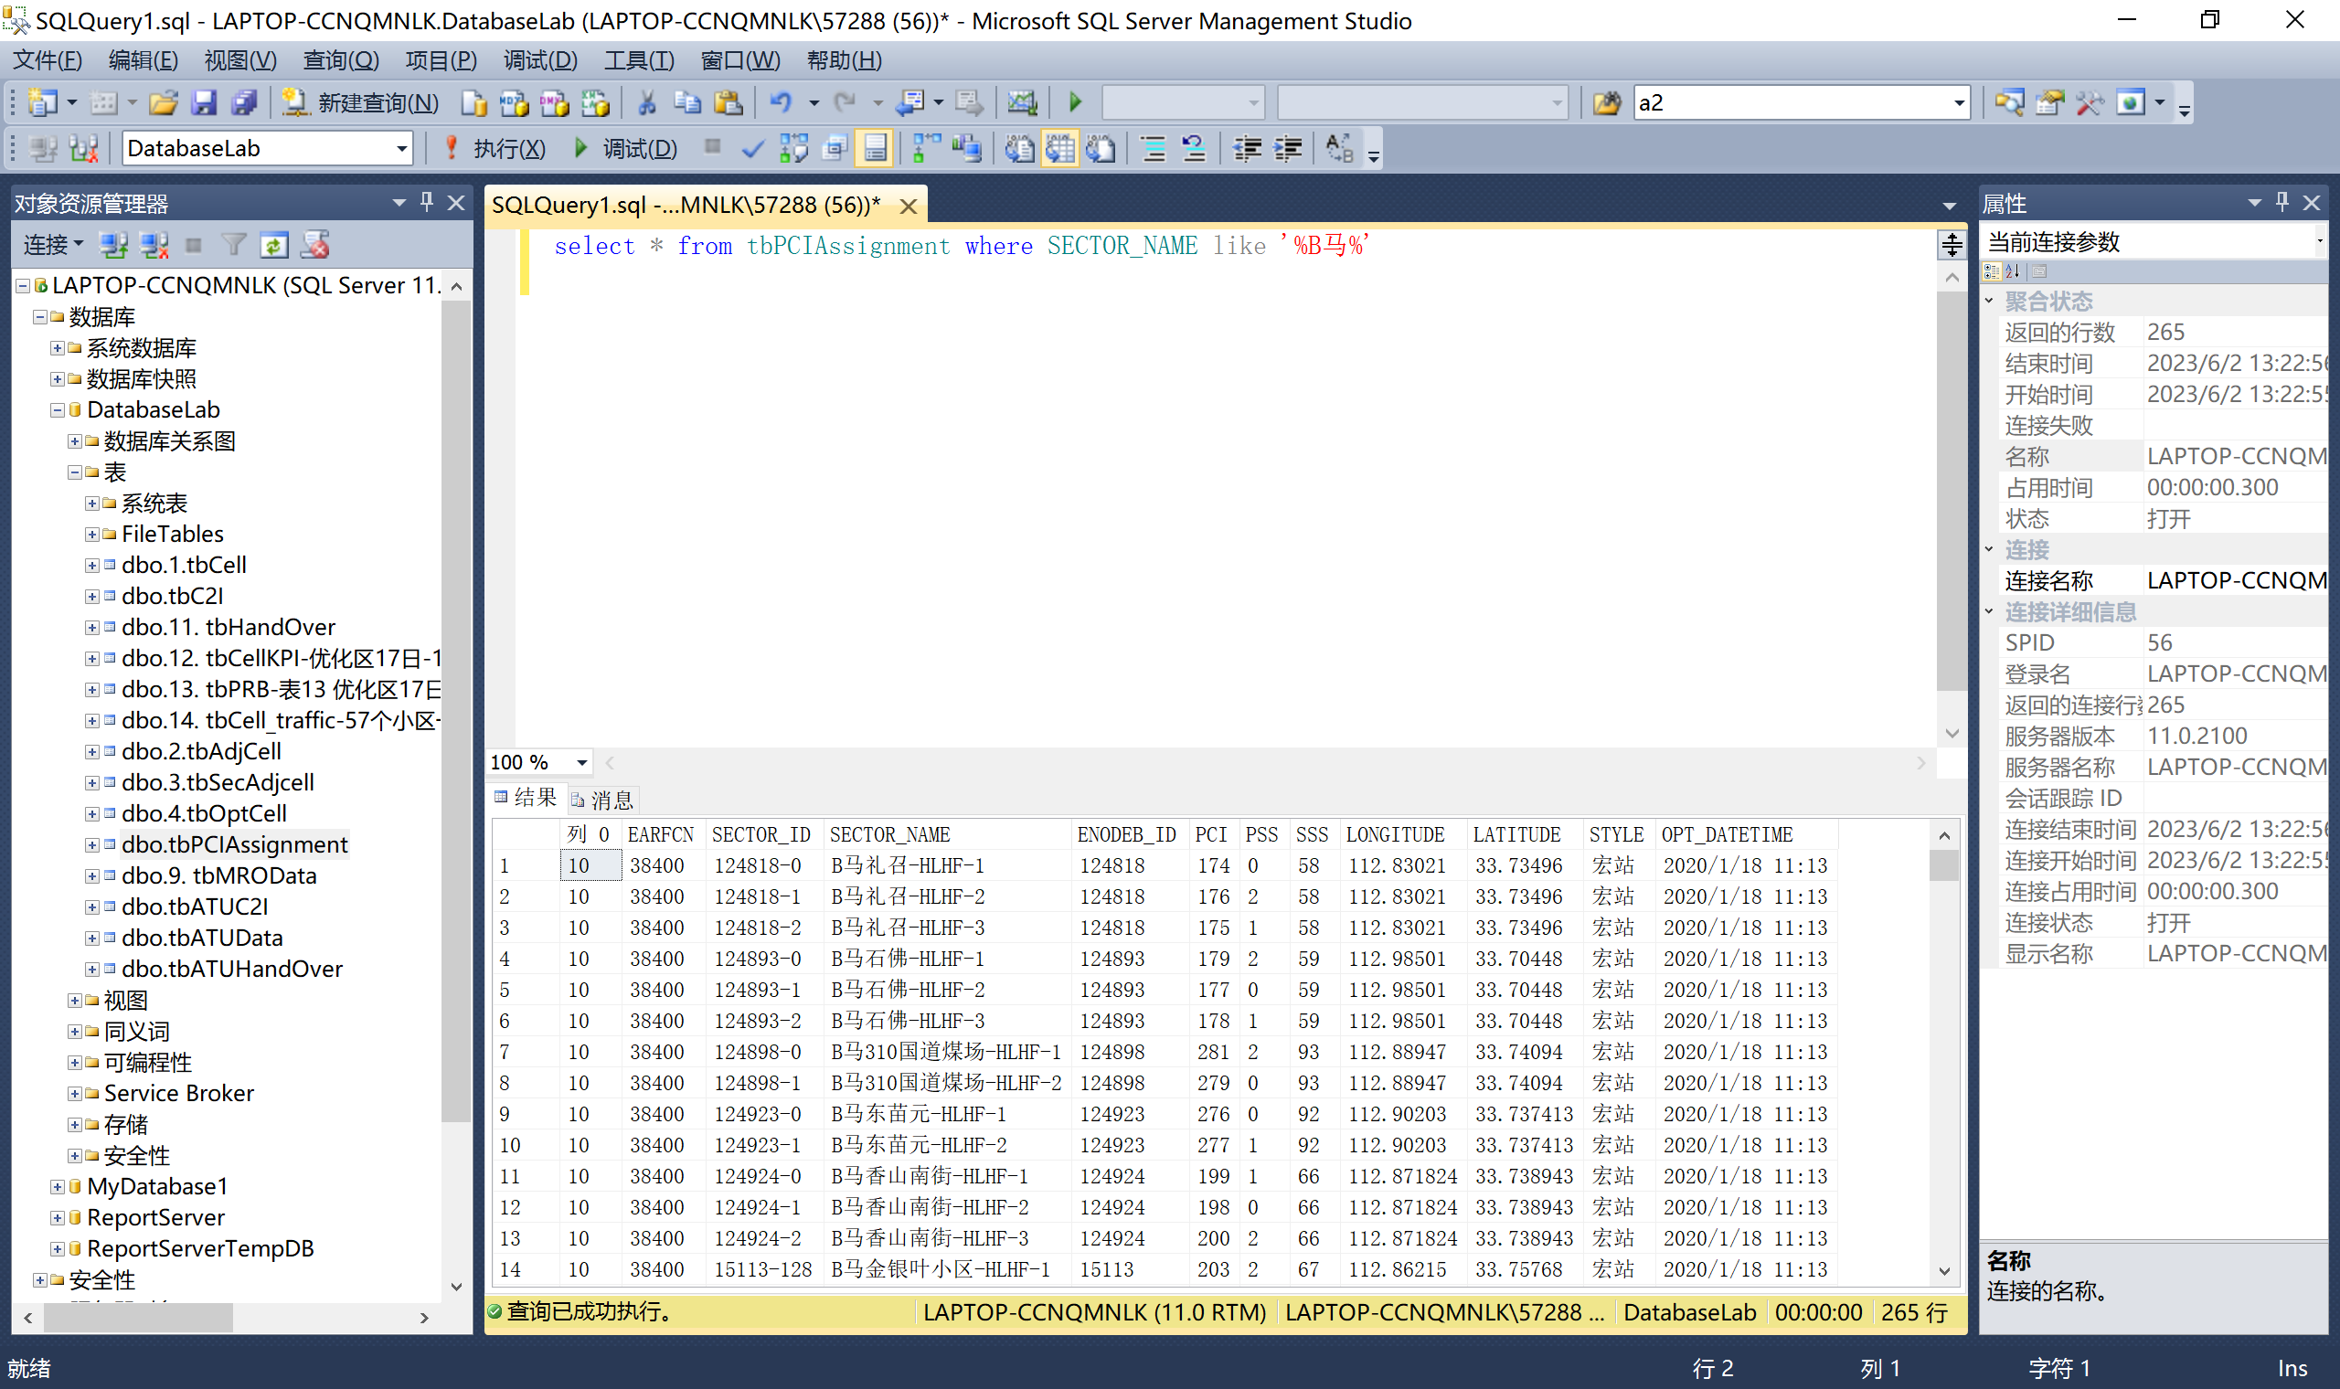

5.2.4 Ordering the Display of Tuples

根据路测ATU切换统计矩阵表，查询各小区的最大切换次数及相应的切换目标小区ID，并按降序排列。

SELECT SSECTOR_ID, NSECTOR_ID, MAX(HOATT) AS HOATT

FROM tbatuhandover

GROUP BY SSECTOR_ID, NSECTOR_ID

ORDER BY HOATT DESC;

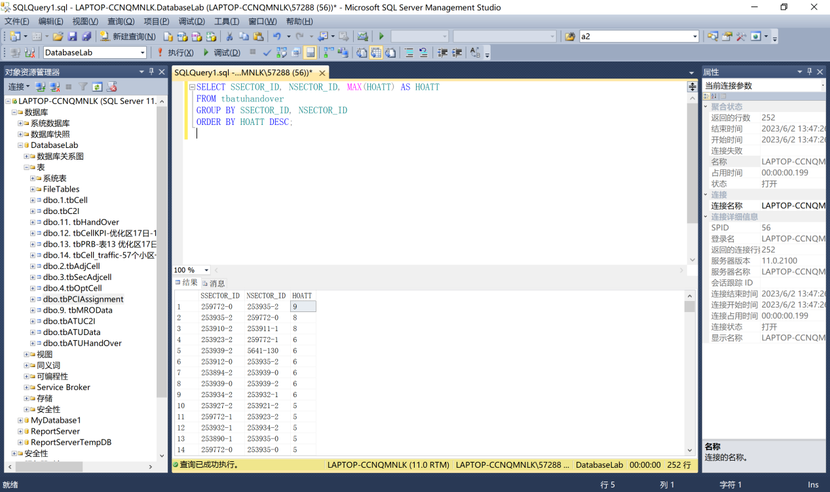

5.2.5 Where Clause Predicates

根据小区/基站工参表和基于MR测量报告的干扰分析表，使用between语句查询经度位于112到113之间、纬度位于33.7到33.9之间的小区的C2I干扰的均值最大的邻小区ID。

select SCELL,NCELL,MAX( C2I_Mean ) as max_C2I_Mean from tbC2I,tbCell

where SECTOR_ID = SCELL

and LONGITUDE between '112' and '113'

and LATITUDE between '33.7' and '33.9'

group by SCELL,NCELL

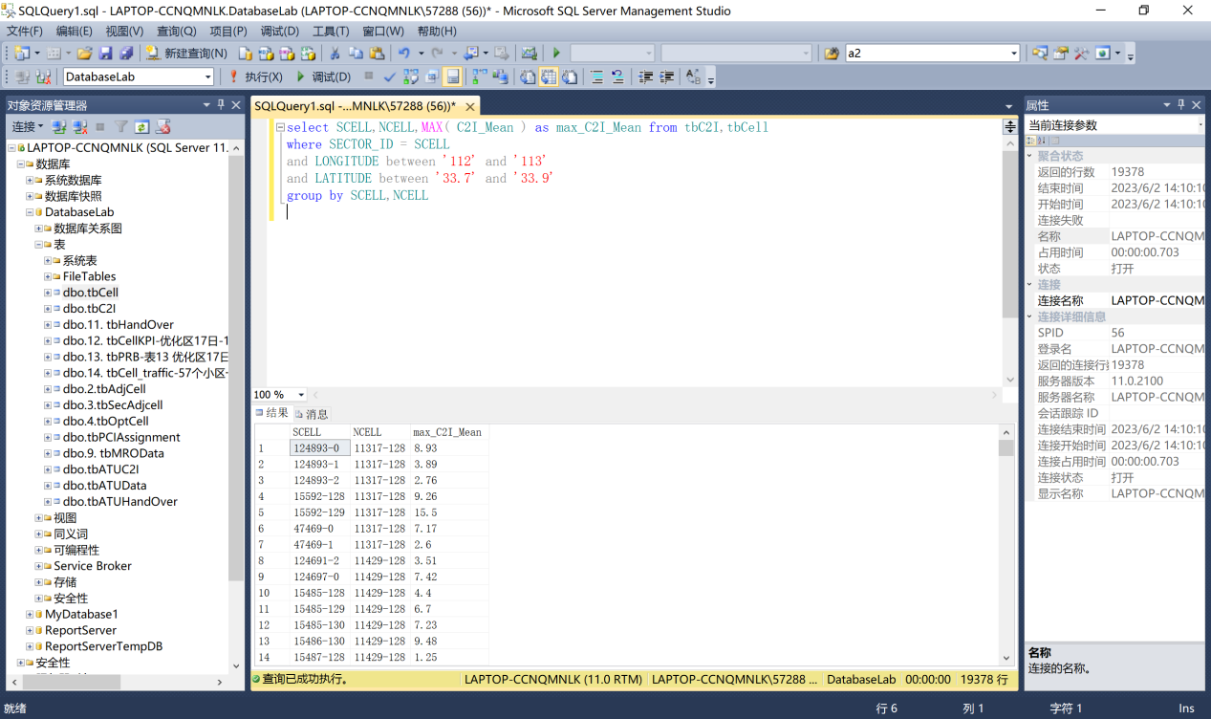

5.3 Set Operation

5.3.1 根据小区/基站工参表，使用union语句中查询所属城市为yiyang、频点为38544，或所属城市为sanxia、频点为38400的小区。

select * from tbCell where CITY = 'yiyang' and EARFCN = '38544'

union

select * from tbCell where CITY = 'sanxia' and EARFCN = '38400'

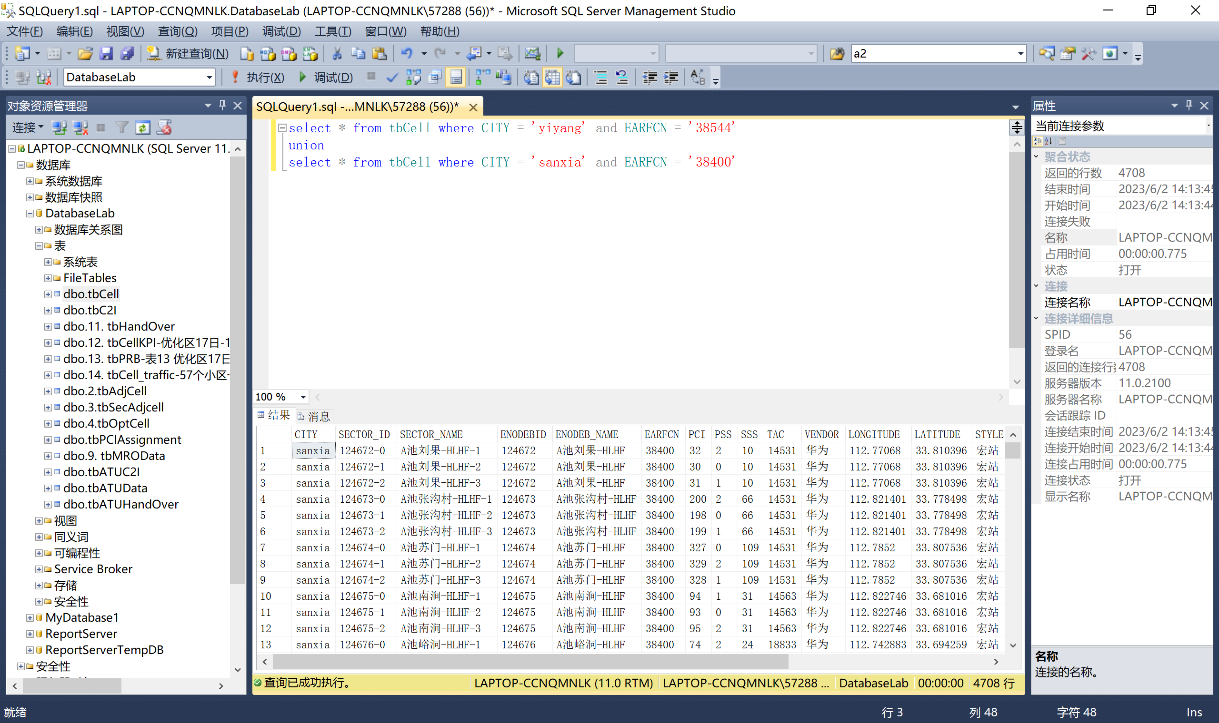

5.3.2根据小区一阶邻区关系表和二阶（同频）邻区关系表，使用intersect语句查询一阶邻区和二阶邻区相同的小区。

select S_SECTOR_ID,N_SECTOR_ID from tbAdjCell

intersect

select S_SECTOR_ID,N_SECTOR_ID from tbSecAdjCell

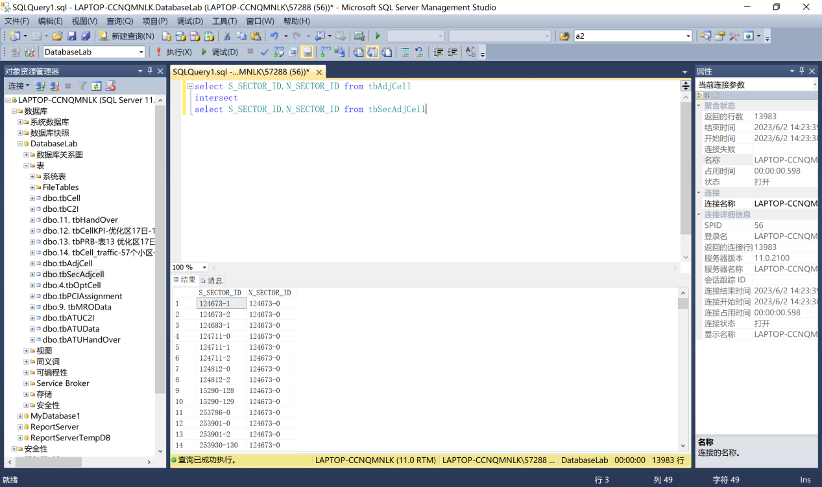

5.3.3根据一阶邻区关系表和二阶（同频）邻区关系表，使用except语句查询二阶邻区不是一阶邻区的小区。

select S_SECTOR_ID,N_SECTOR_ID from tbAdjCell

except

select S_SECTOR_ID,N_SECTOR_ID from tbSecAdjCell

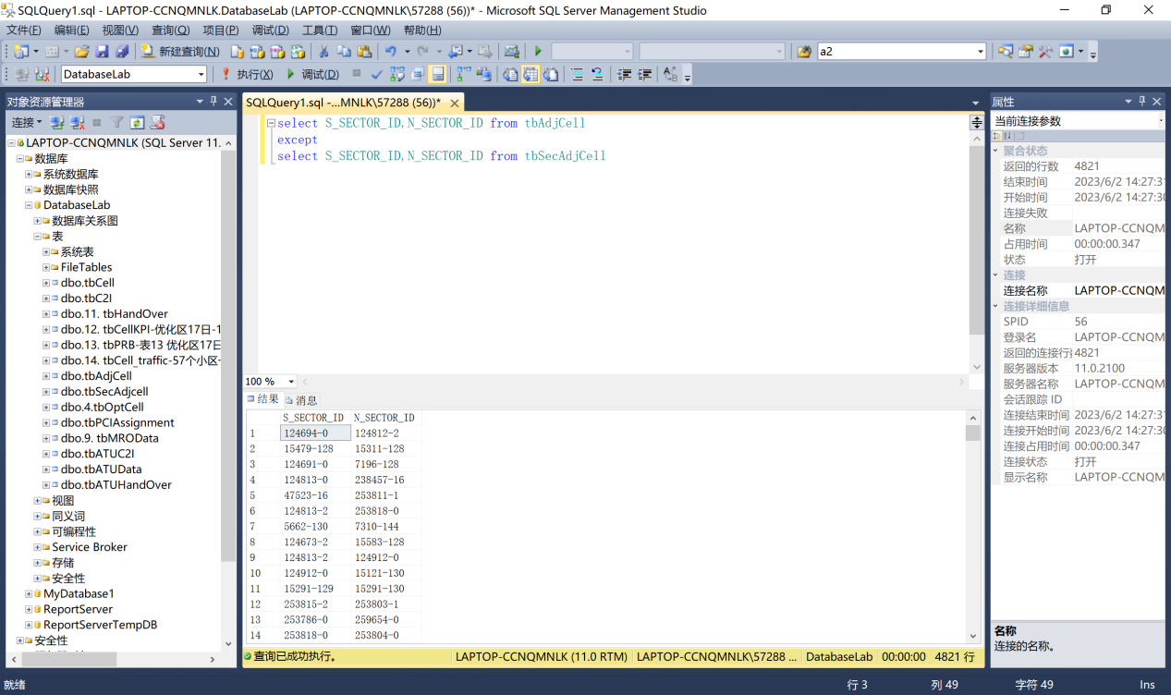

5.3.4 根据路测ATU C2I干扰矩阵表，使用except语句查询主小区和邻小区间干扰强度最大的小区。

select SECTOR_ID,RATIO_ALL from tbatuc2i

except

select a.SECTOR_ID,a.RATIO_ALL

from tbatuc2i as a,tbatuc2i as b

where a.RATIO_ALL < b.RATIO_ALL

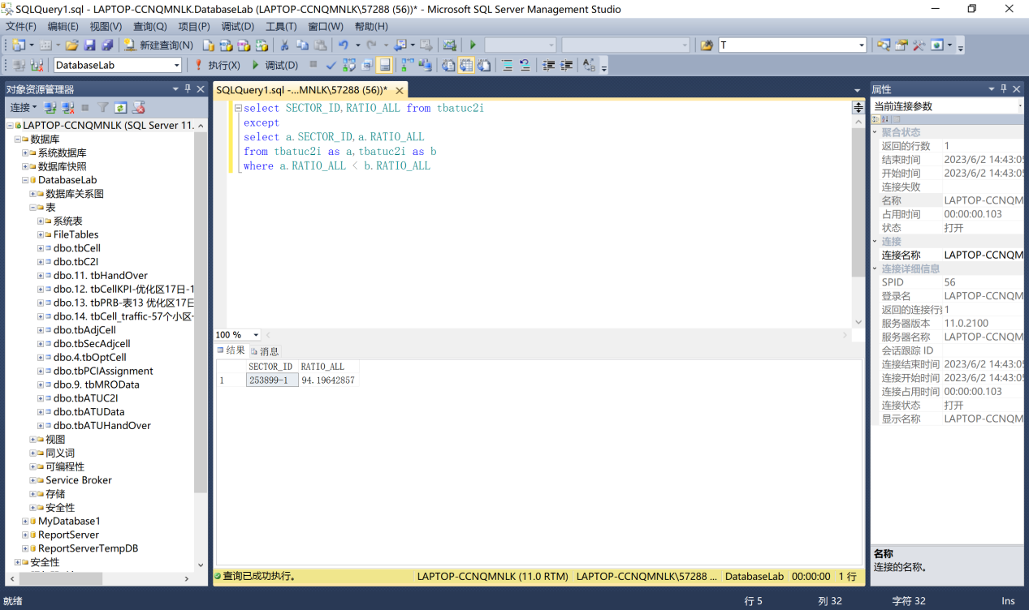

5.4 Null Values

根据路测ATU数据表，查询第1邻小区/干扰小区物理小区标识不为空的服务小区ID、服务小区PCI。

select CellID,PCI from tbATUData

where NCell_PCI_1 is not null AND LEN(rtrim( NCell_ID_1 ))> 0;

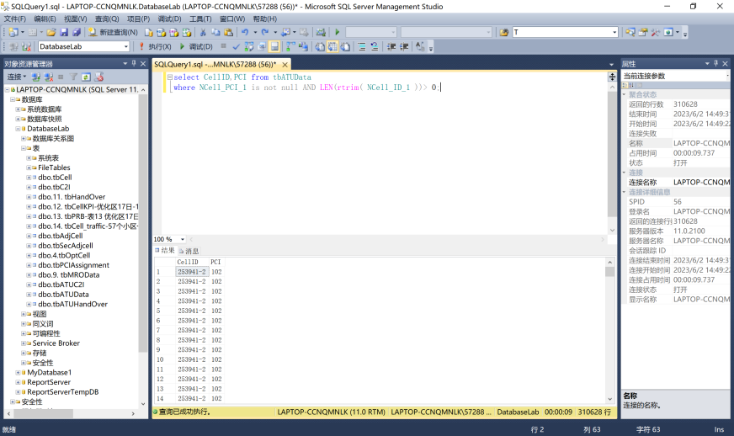

5.5 Aggregate Functions

5.5.1 根据优化小区/保护带小区表和小区一阶邻区关系表，查询一阶邻区数大于10的优化小区，并将查询结果降序排列。

select SECTOR_ID,count(N_SECTOR_ID)as t

from tbOptCell,tbAdjCell

where S_SECTOR_ID = SECTOR_ID

group by SECTOR_ID

having count(N_SECTOR_ID)>10

ORDER BY t DESC;

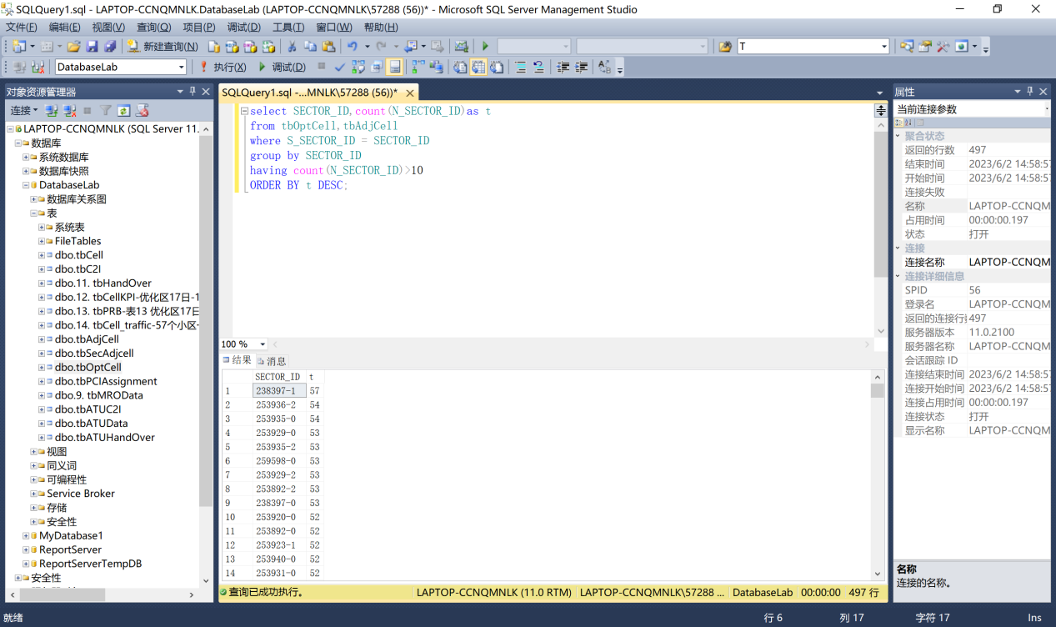

5.5.2 根据小区/基站工参表和路测ATU数据表，查询所属基站为“253903”的小区的最大信噪比SINR，最小信噪比SINR，平均信噪比SINR。

select max(CONVERT(float, RS_SINR))as max,

min(CONVERT(float, RS_SINR))as min,

avg(CONVERT(float, RS_SINR))as avg

from tbATUData,tbCell

where ENODEBID = '253903'

and tbCell.SECTOR_ID = tbATUData.CellID

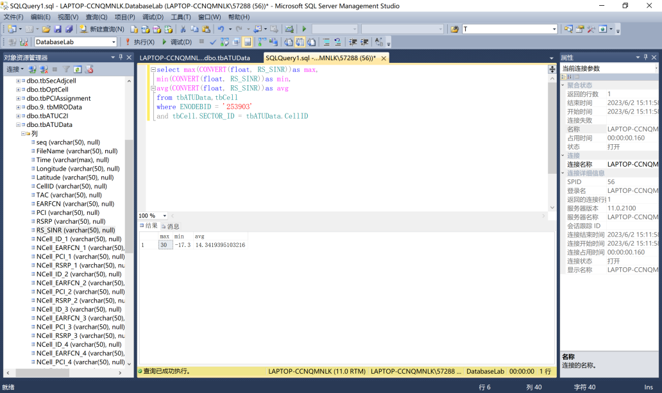

5.6 Nested (嵌套) Subqueries

5.6.1 Set Membership

根据优化小区/保护带小区表和小区PCI优化调整结果表，查询小区类型为“优化区”的小区经调整后的PCI。

select SECTOR_ID,SECTOR_NAME,PCI from tbPCIAssignment

where tbpciassignment.SECTOR_ID

IN (select SECTOR_ID from tboptcell where CELL_TYPE = '优化区')

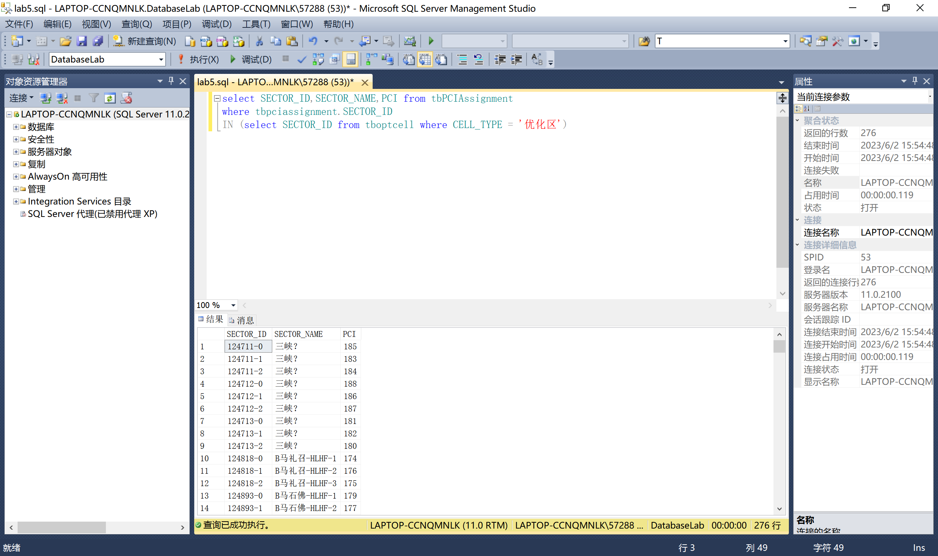

5.6.2 Set Comparison – “some” Clause

1. 根据路测ATU数据表和小区/基站工参表，使用some语句查询“服务小区参考信号接收功率RSRP”大于部分（至少一个）所属基站ID为5660的小区的“服务小区参考信号接收功率RSRP”的服务小区。

select * from tbATUData where RSRP > some(select RSRP from tbATUData,tbCell

where tbCell.SECTOR_ID = tbATUData.CellID and tbCell.ENODEBID='5660')

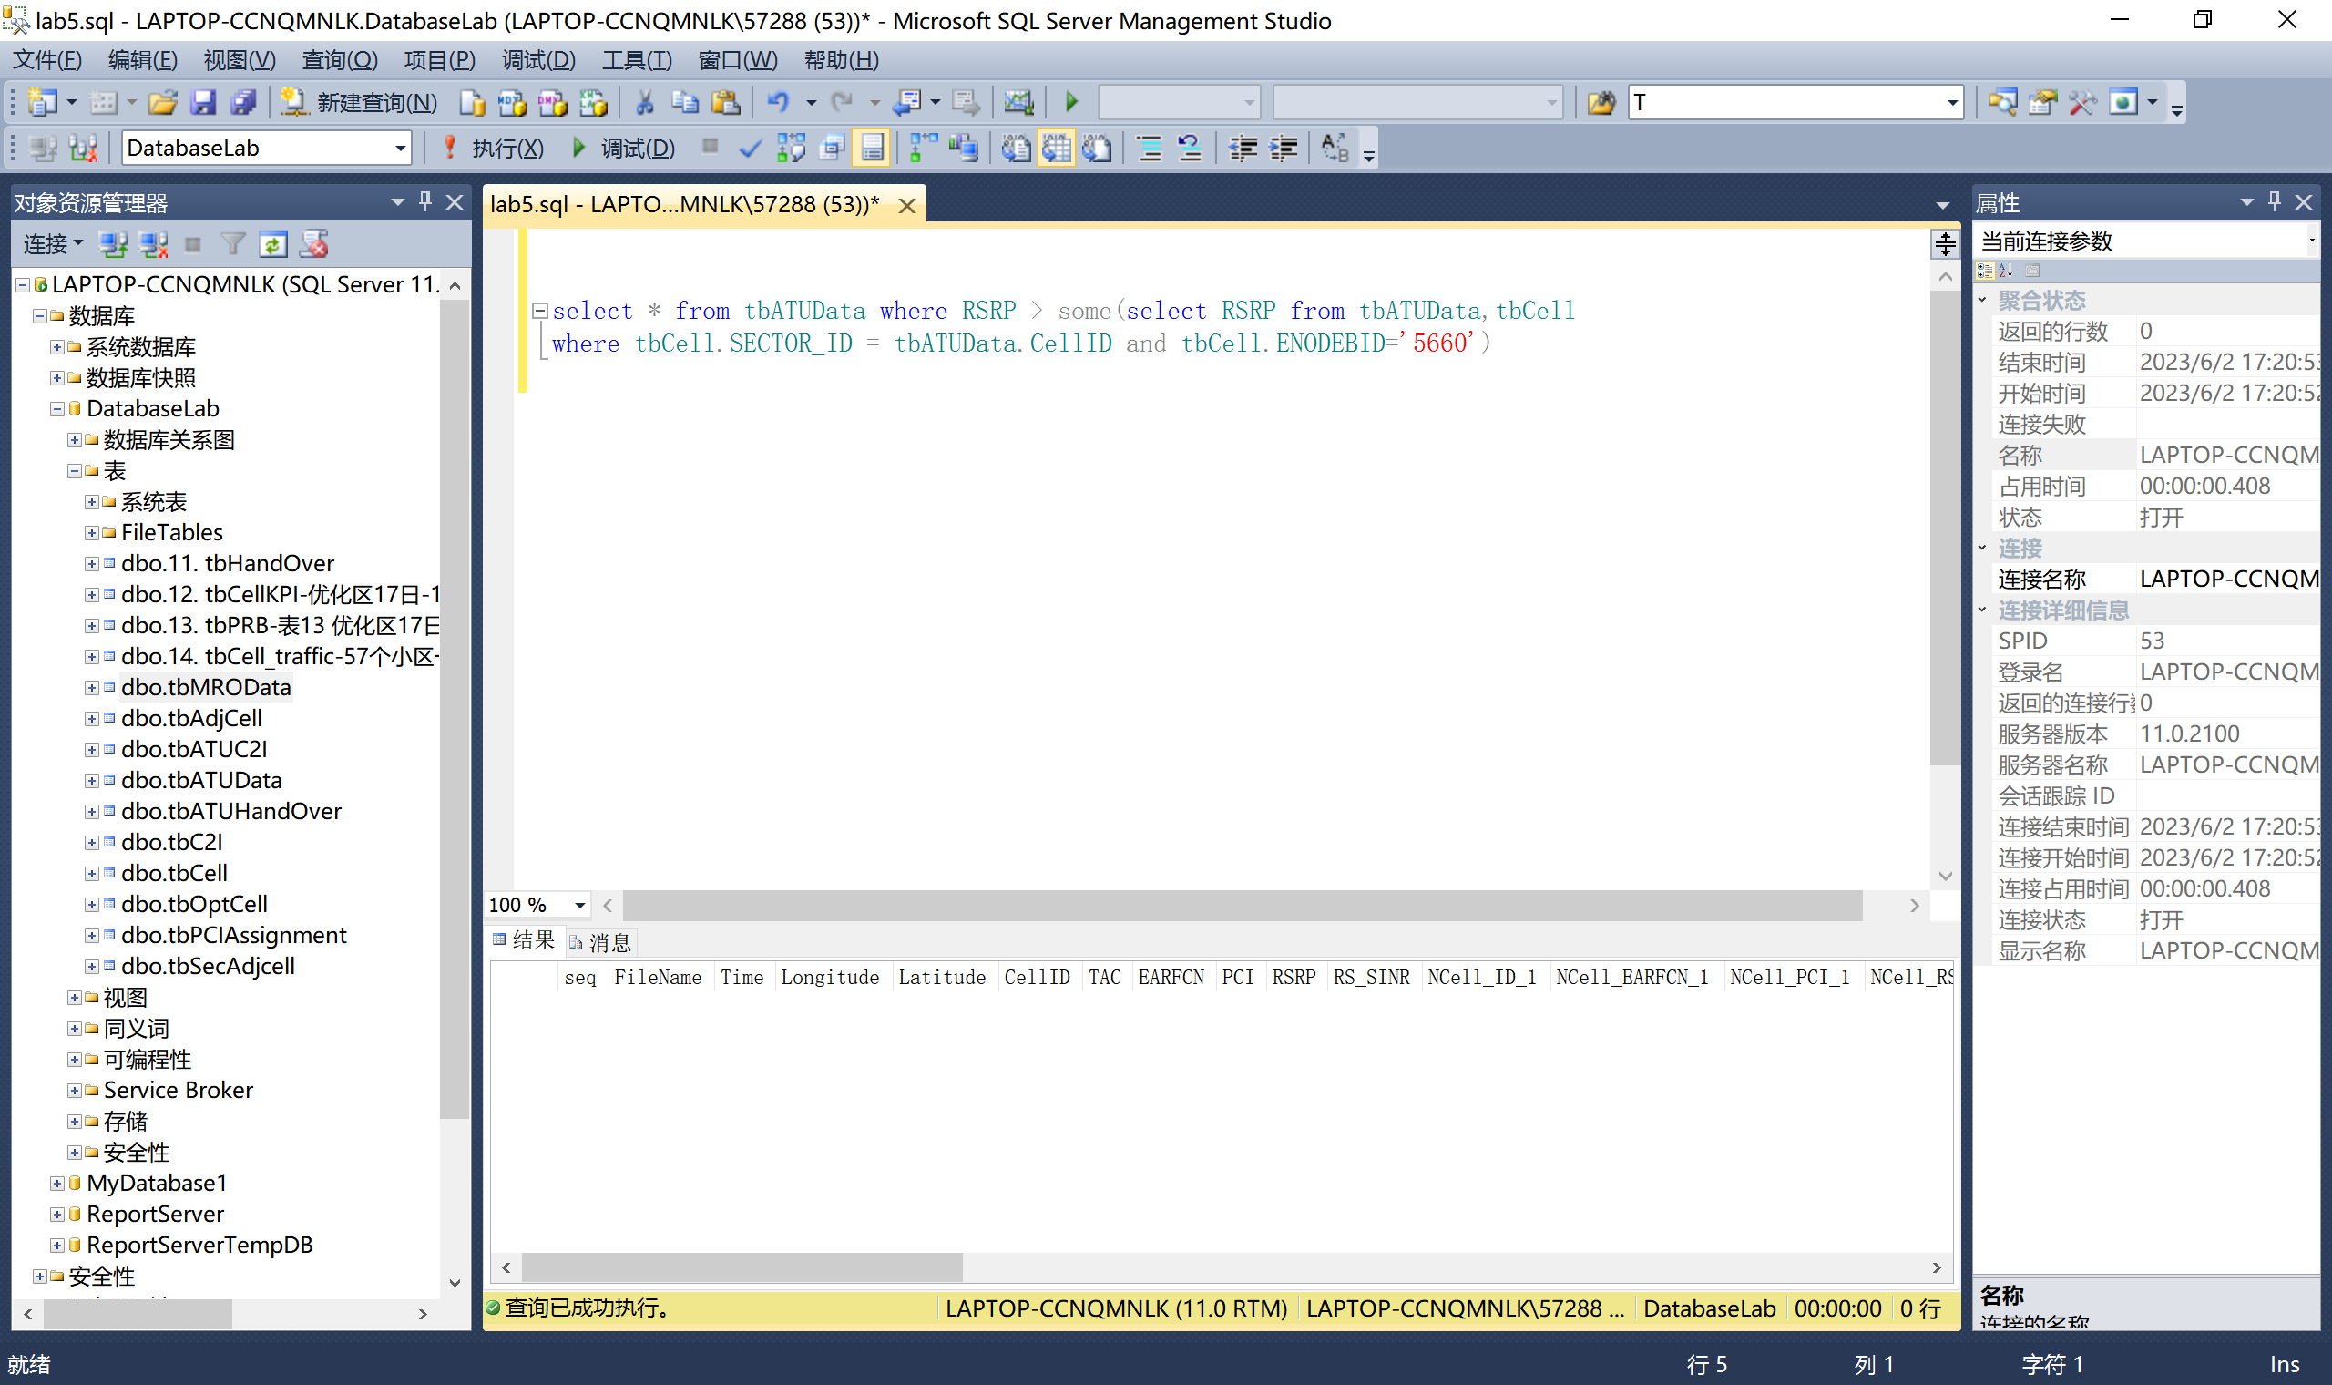

2. 根据路测ATU切换统计矩阵表和MRO测量报告数据表，使用all语句查询切换次数最多的小区的干扰小区ID，干扰小区PCI。

select InterferingSector,LteNcPci from tbMROData where ServingSector

in (select SSECTOR_ID from tbATUHandOver where HOATT >= all(select HOATT from tbATUHandOver))

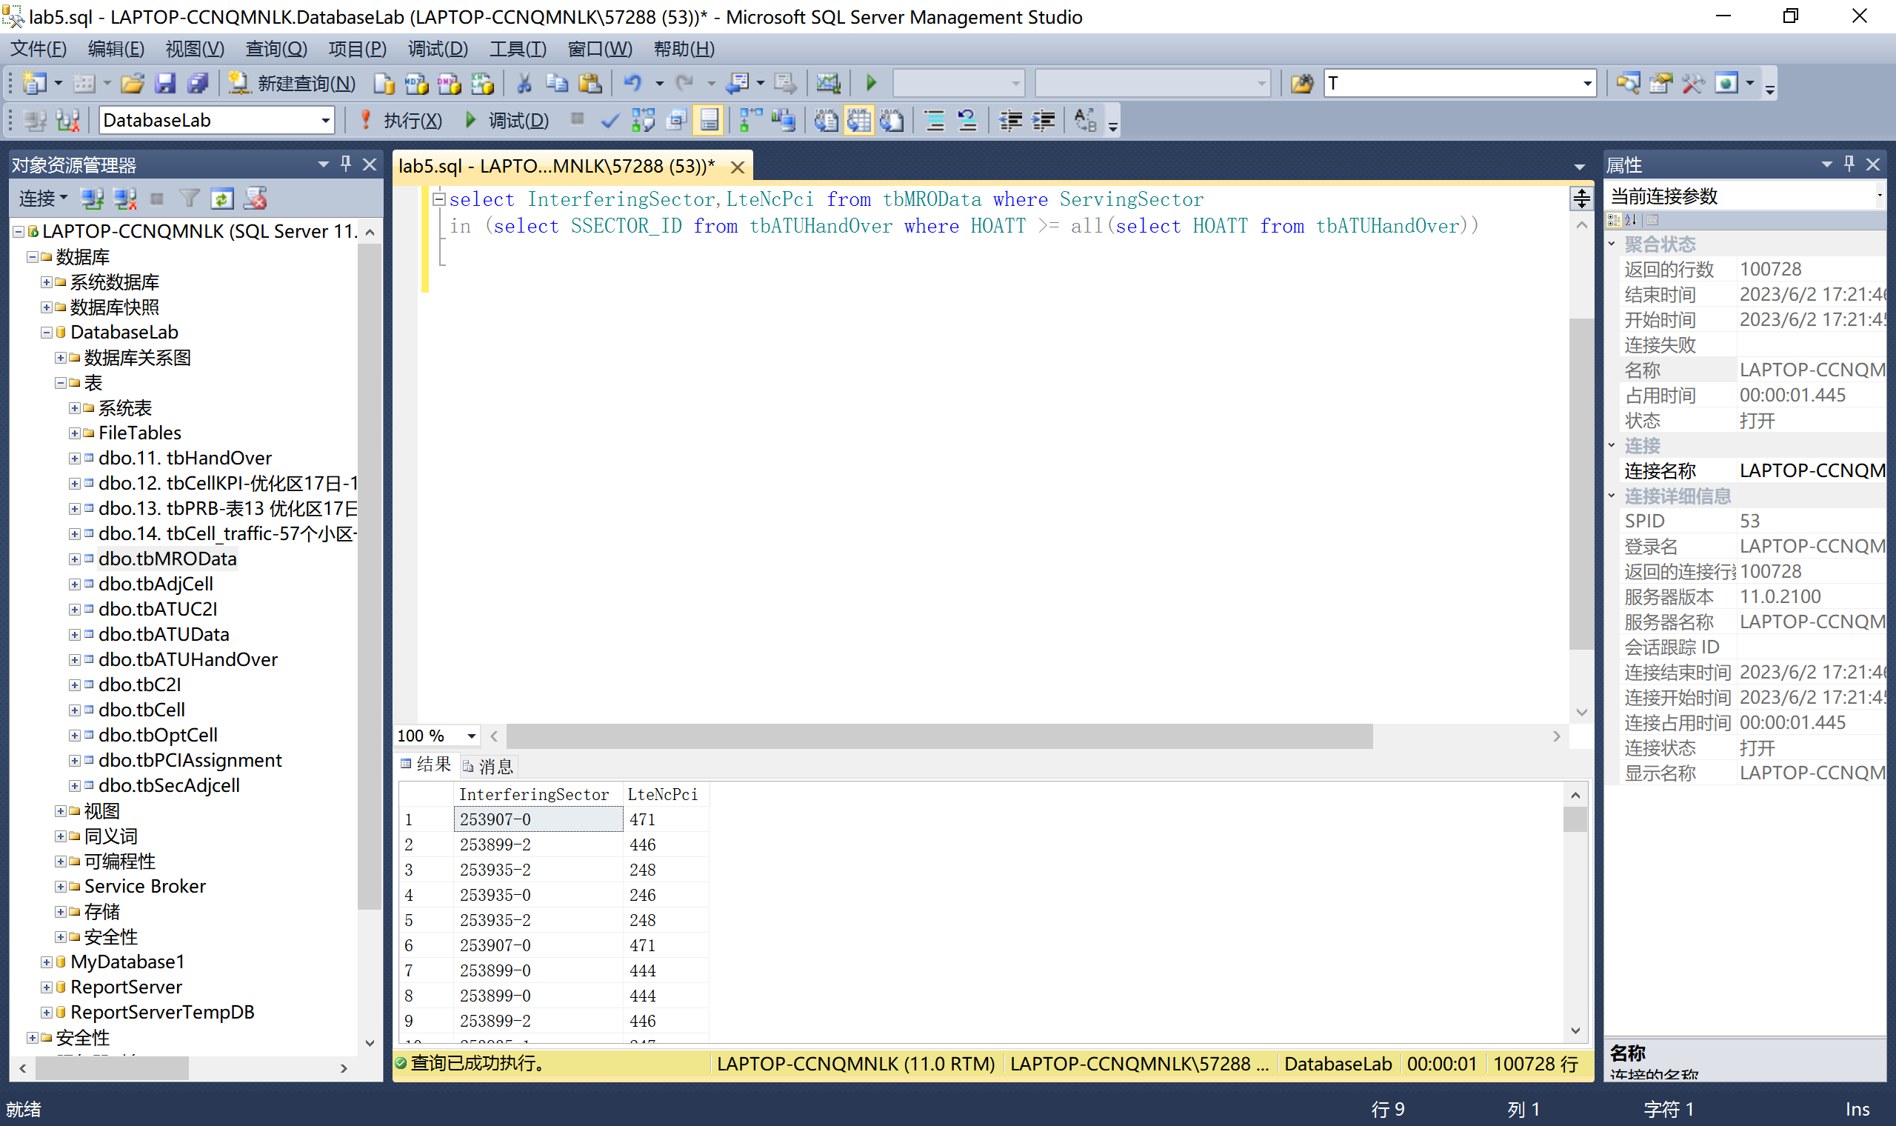

5.6.3 Test for Empty Relations---Use of “not exists” Clause

根据路测ATU数据表和优化小区表，使用not exists语句查询小区类型不为保护带小区的第1邻小区/干扰小区的标识、第1邻小区/干扰小区频点、第1邻小区/干扰小区物理小区标识、第1邻小区/干扰小区参考信号接收强度。

select

NCell_ID_1,

NCell_PCI_1,

NCell_RSRP_1,

NCell_EARFCN_1

from

tbatudata

where

NOT EXISTS

( select * from tboptcell

where tbatudata.CellID = tboptcell.SECTOR_ID and CELL_TYPE = '保护带' )

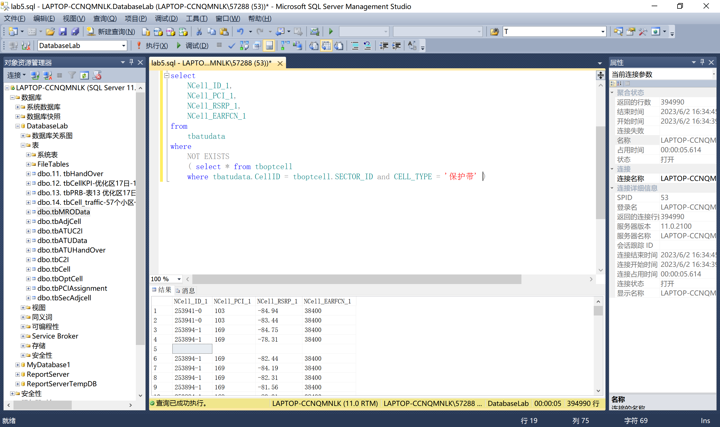

5.6.4 Test for Absence of Duplicate Tuples

根据基于MR测量报告的干扰分析表和路测ATU切换统计矩阵表，查询主小区ID在路测ATU切换统计矩阵表中只出现过一次的加权C2I干扰。

select

WeightedC2I

from

tbc2i

where

SCELL in ( select SSECTOR_ID from tbatuhandover

group by SSECTOR_ID having count( * ) = 1 )

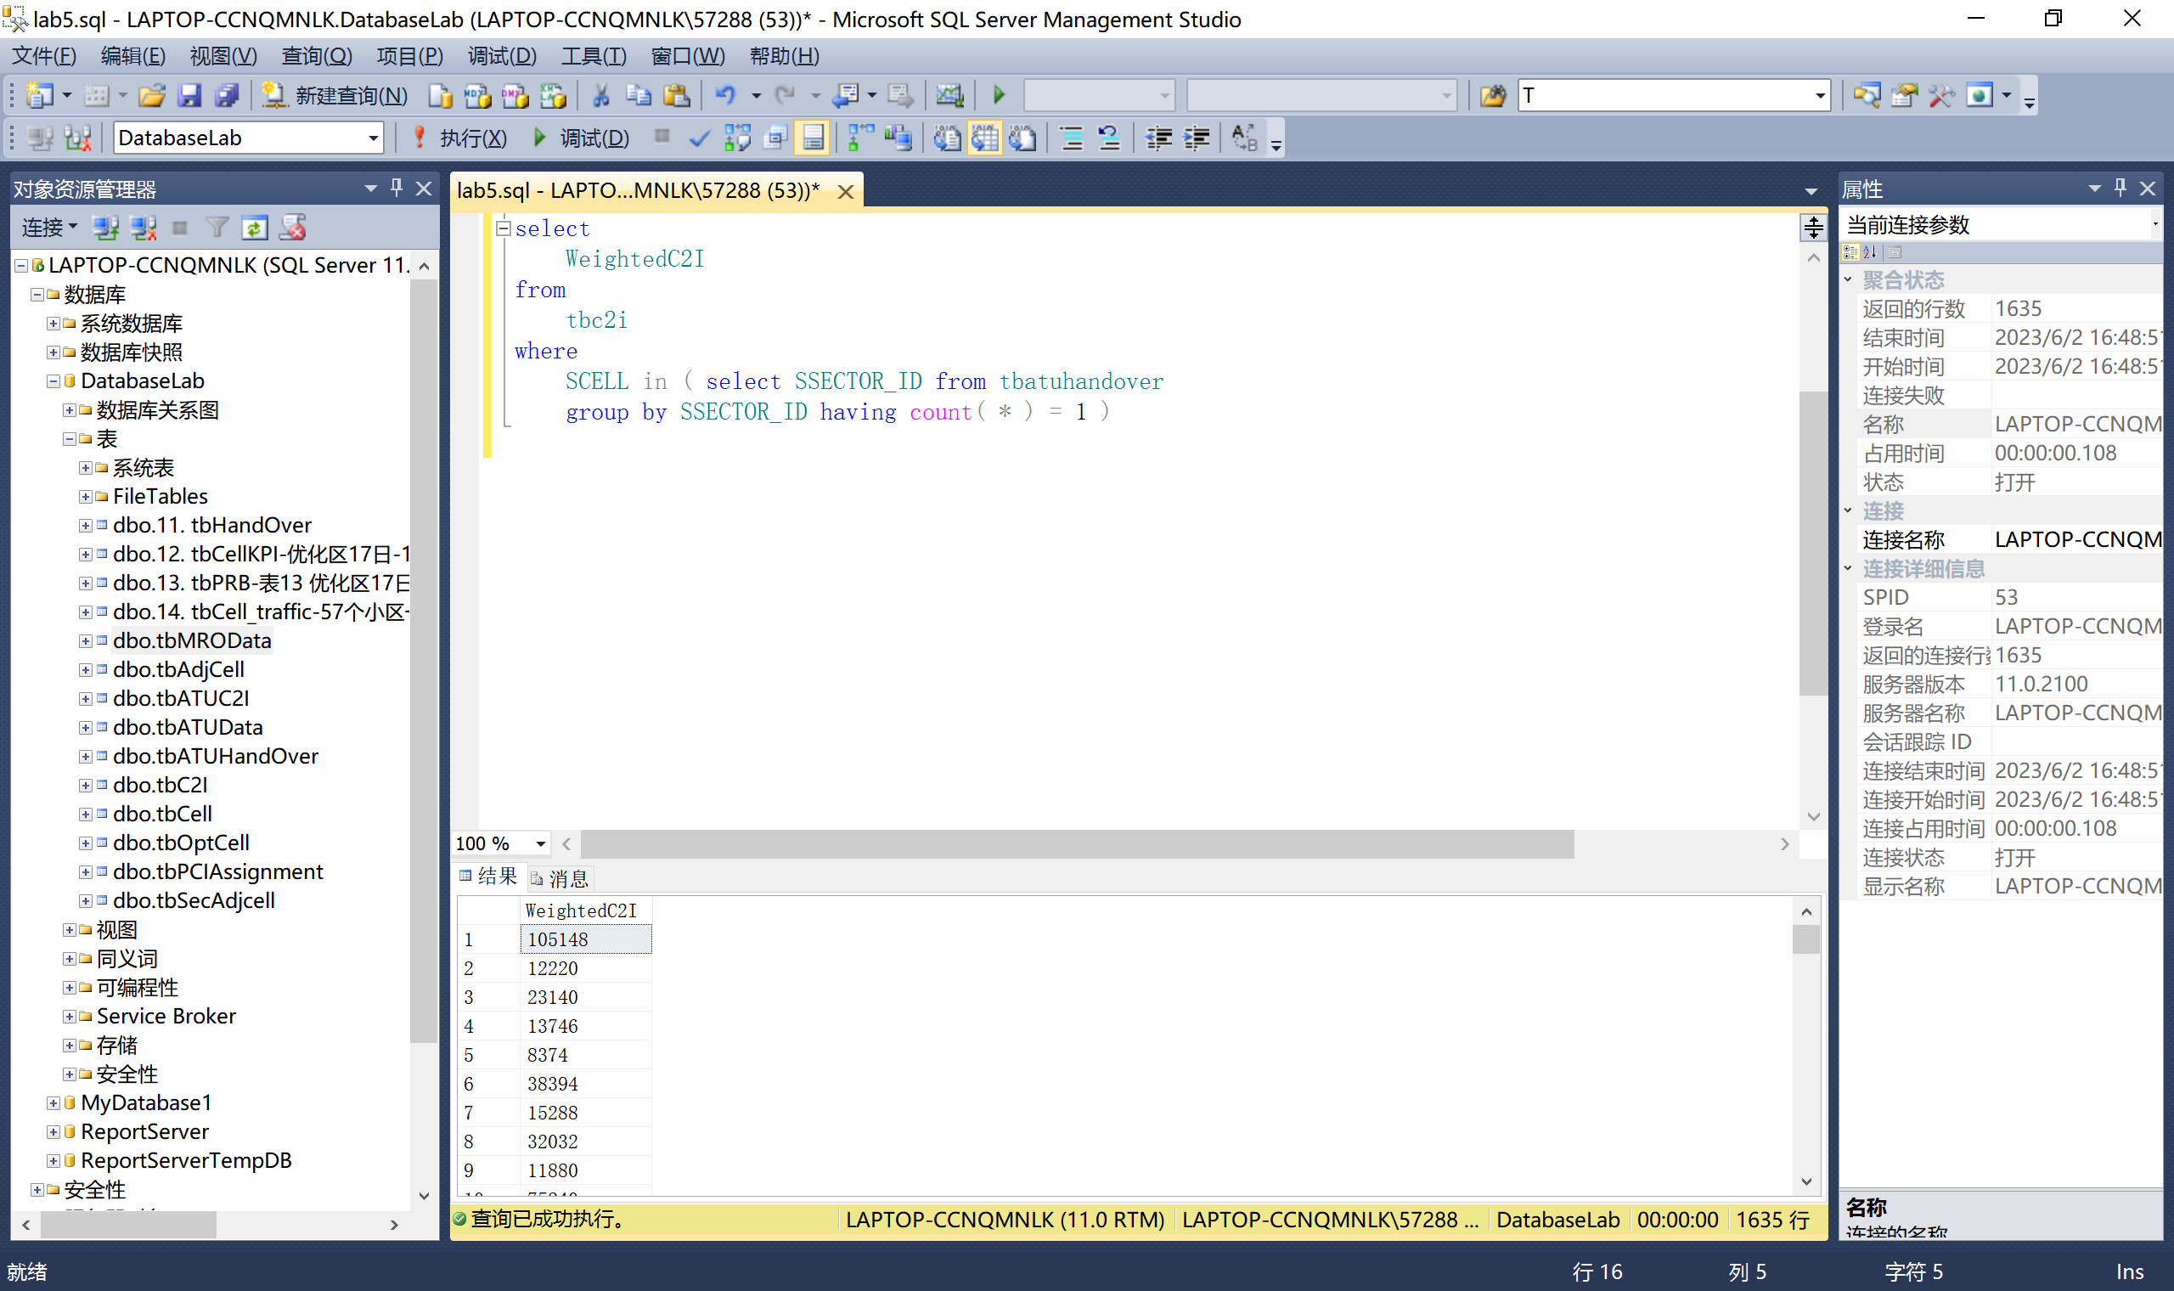

5.6.5 Subqueries in the From Clause

根据路测ATU数据表，查询服务小区参考信号接收功率RSRP的均值大于-70的小区。

select CellID from tbATUData group by CellID having avg(CONVERT(float,RSRP))>-70

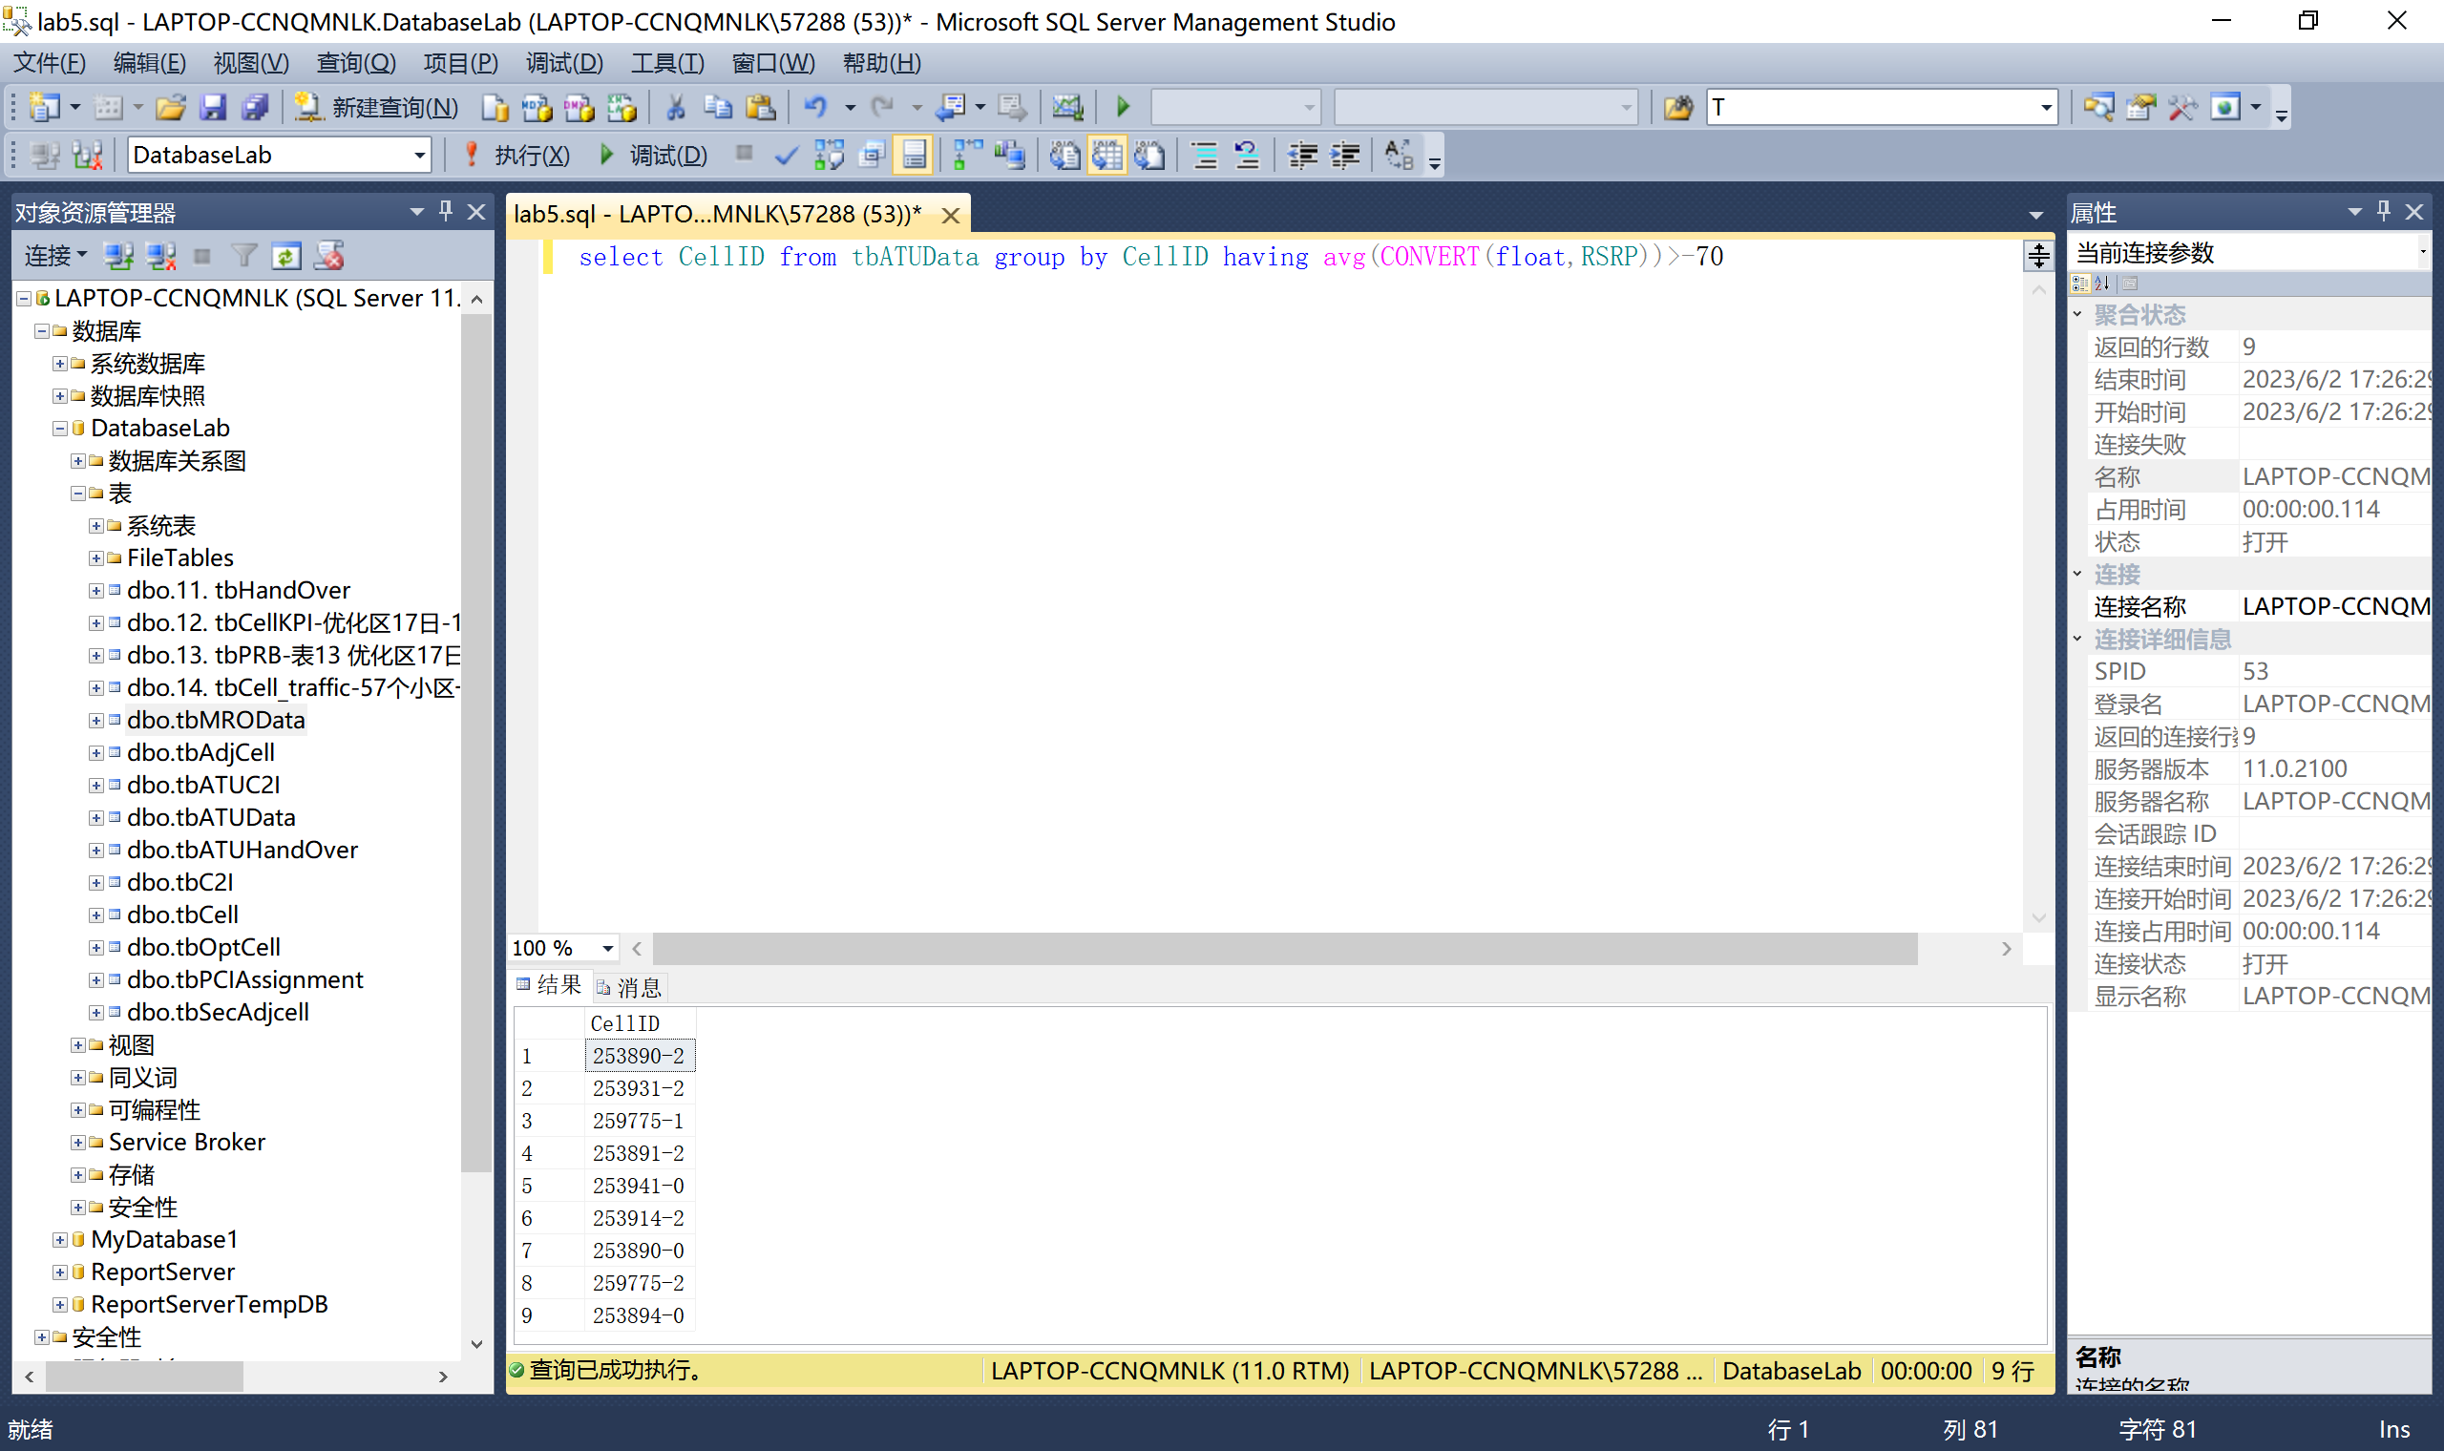

5.6.6 With Clause

根据路测ATU切换统计矩阵表和MRO测量报告数据表，使用with语句找出所有具有最低切换次数的小区的MRO测量信息。

with Min as

( select SSECTOR_ID from tbatuhandover

where HOATT <= ANY ( select HOATT from tbHandOver ) )

select distinct * from tbMROData,Min where ServingSector = SSECTOR_ID

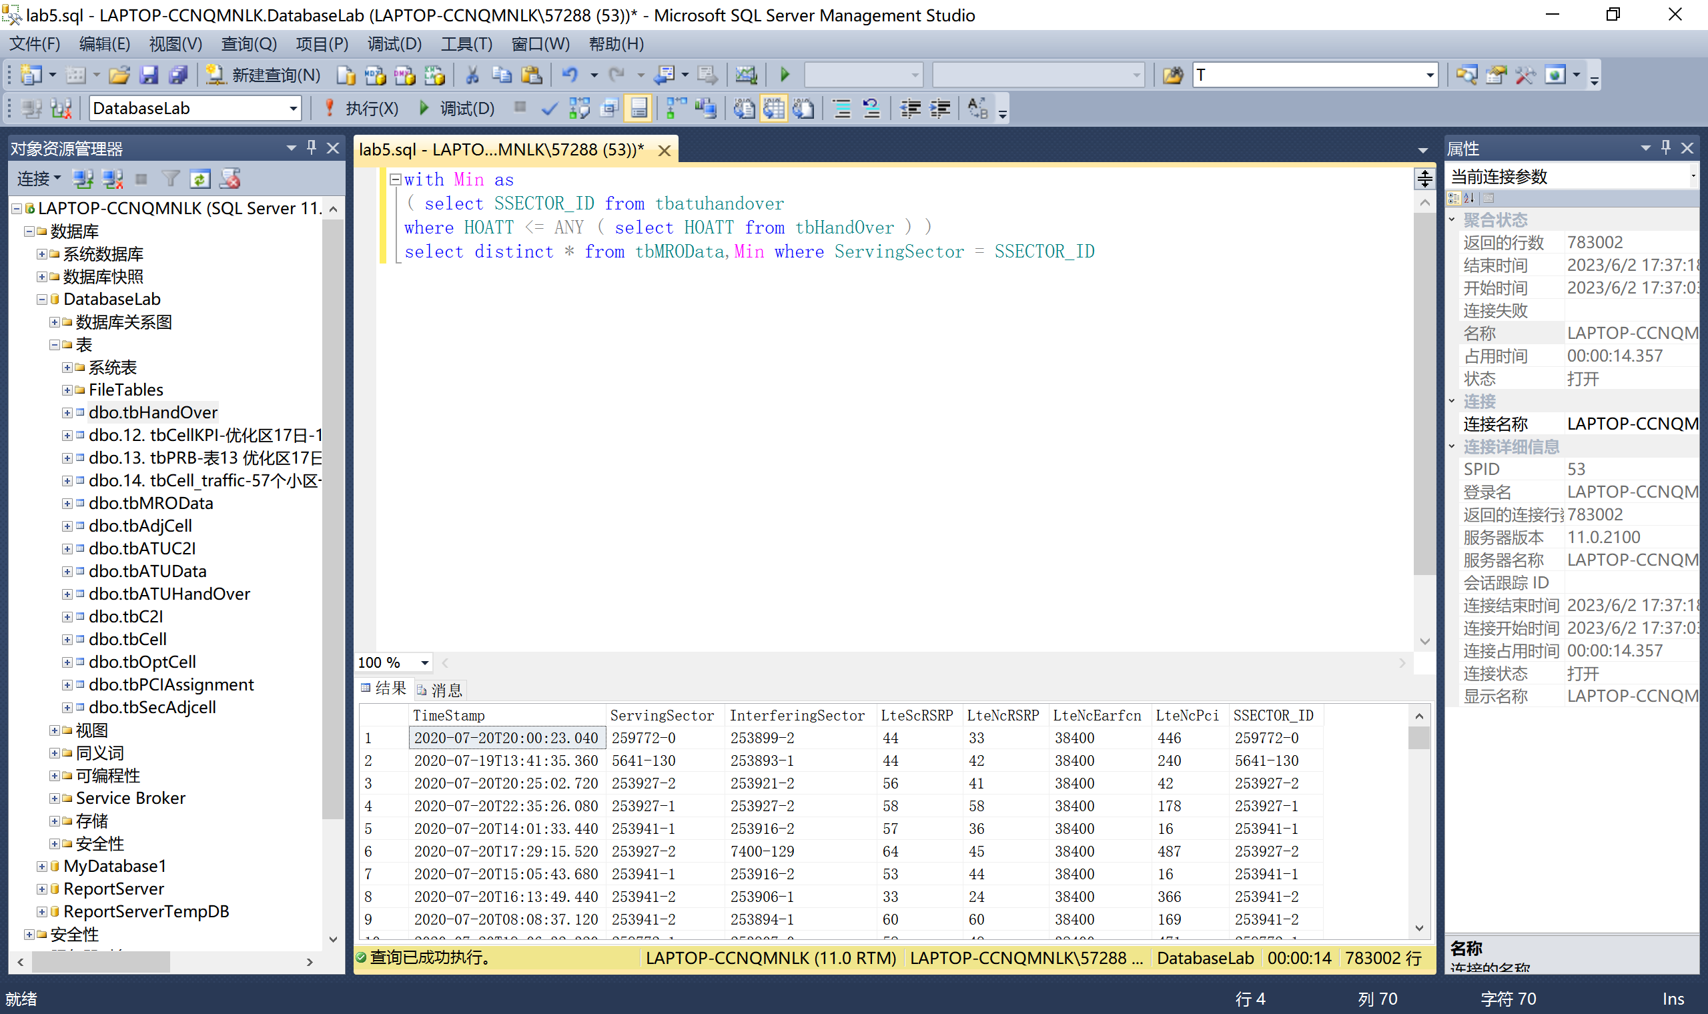

5.6.7 Scalar Subquery——Subqueries in the Select Clause

根据小区/基站工参表和一阶邻区关系表，列出频点为38400的所有小区的一阶邻区数目。

select count(N_SECTOR_ID)as 一阶邻区数目 from tbAdjCell where S_SECTOR_ID in

(select SECTOR_ID from tbCell where EARFCN = '38400') group by S_SECTOR_ID

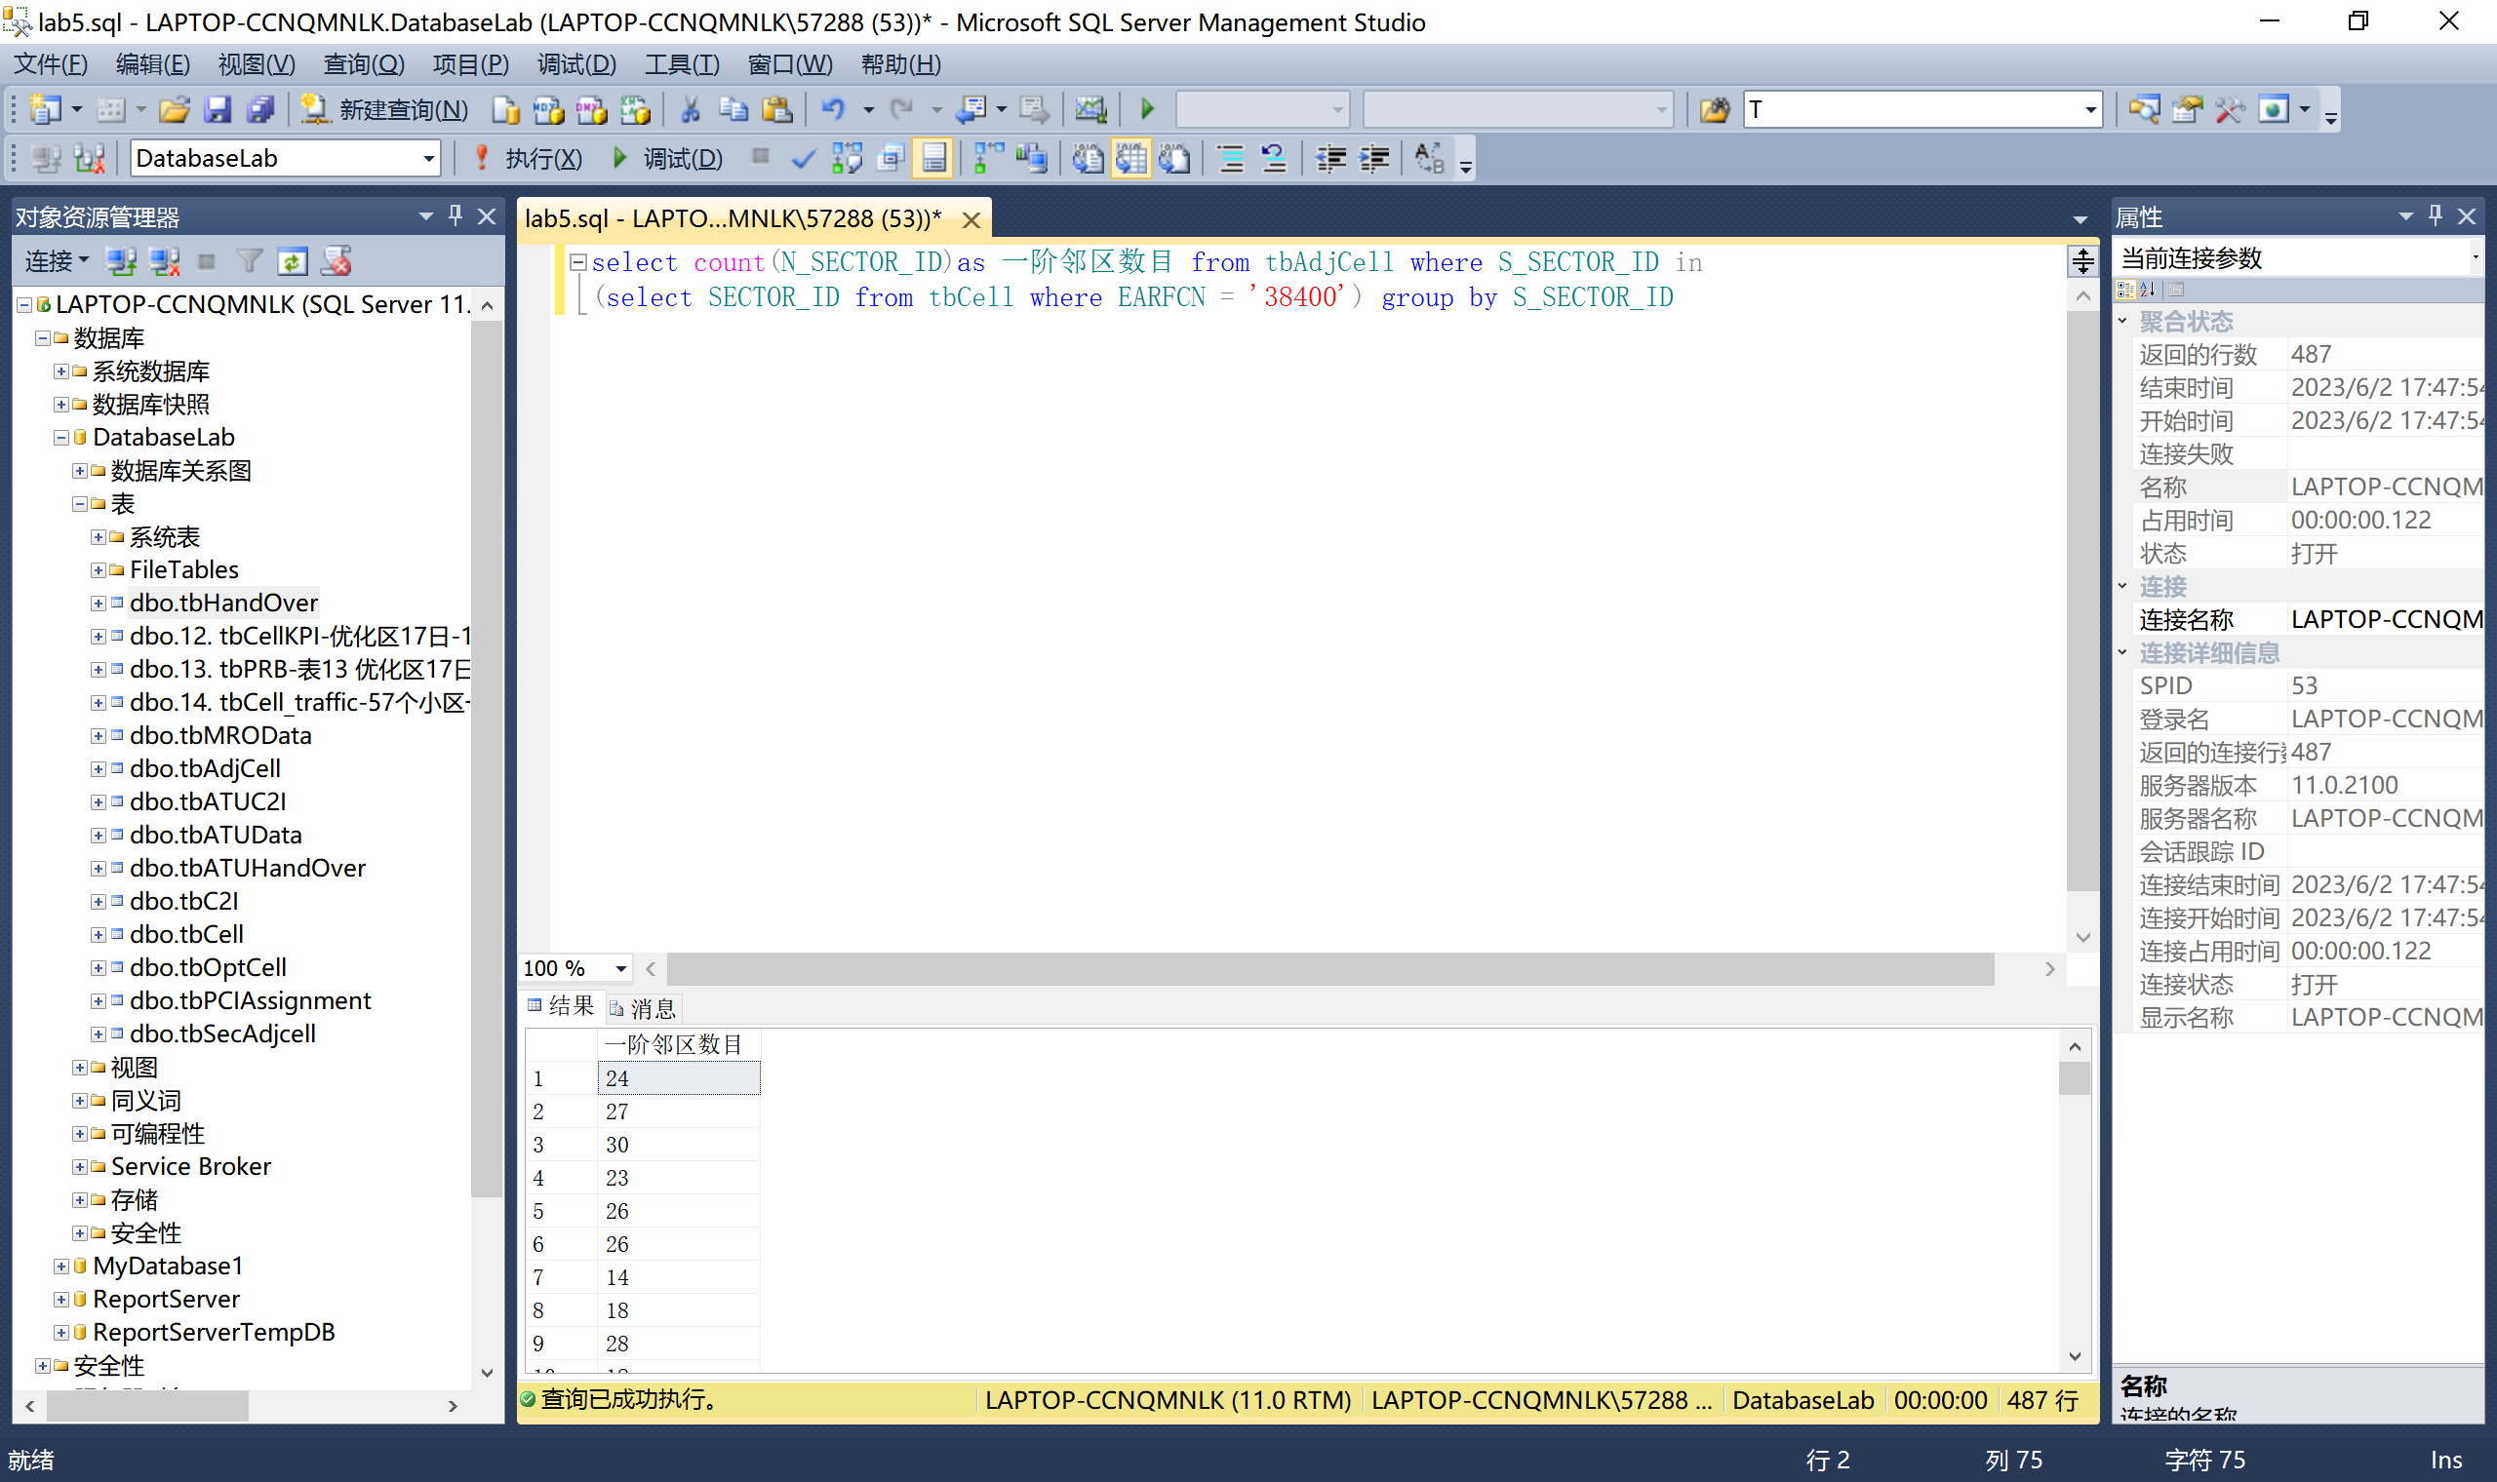

5.7 综合---查询语句

根据小区/基站工参表和小区切换统计性能表，查询具有最多二阶邻区数的小区的最大切换成功次数、相应的切换目标小区ID、尝试切换次数。

5.8 Modification of the Database

5.8.1 Deletion

根据路测ATU切换统计矩阵表和小区切换统计性能表，删除切换次数均值小于3的小区切换性能统计数据。

with temp(id) as

(SELECT top (1) S_SECTOR_ID

FROM tbSecAdjCell

GROUP BY S_SECTOR_ID

ORDER BY COUNT(N_SECTOR_ID)

DESC)

SELECT top 1 SCELL,MAX(CONVERT(float,HOSUCC)) as maxHOSUCC, NCELL, HOATT

FROM tbHandOver, temp

WHERE SCELL = id

GROUP BY SCELL,NCELL, HOATT

order by MAX(CONVERT(float,HOSUCC)) desc

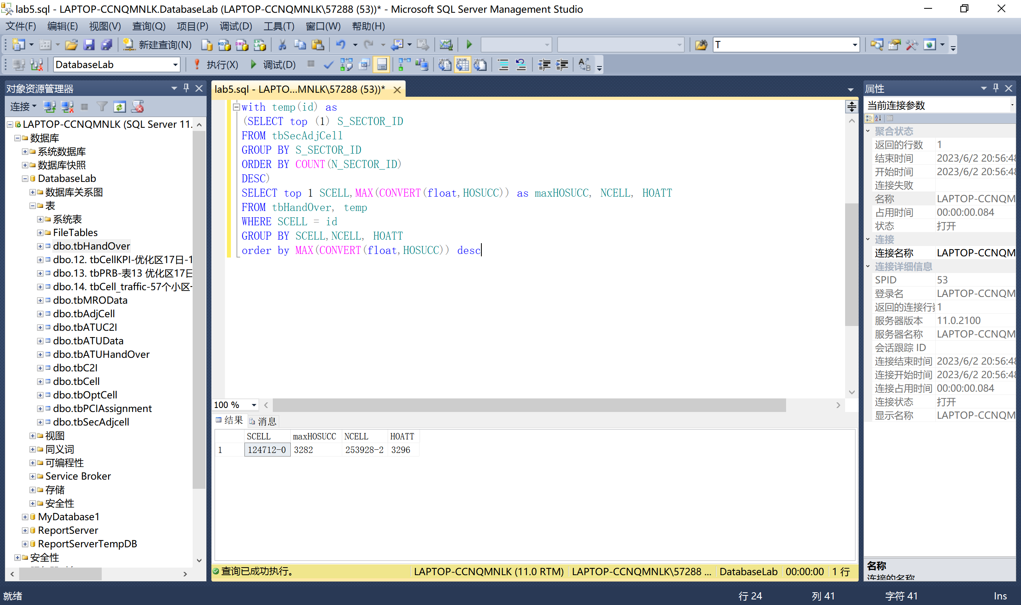

5.8 Modification of the Database

5.8.1 Deletion

根据路测ATU切换统计矩阵表和小区切换统计性能表，删除切换次数均值小于3的小区切换性能统计数据。

delete

from tbhandover

where tbhandover.SCELL

IN (select SSECTOR_ID

from tbatuhandover

group by SSECTOR_ID having avg(CONVERT(float,HOATT))< 3 )

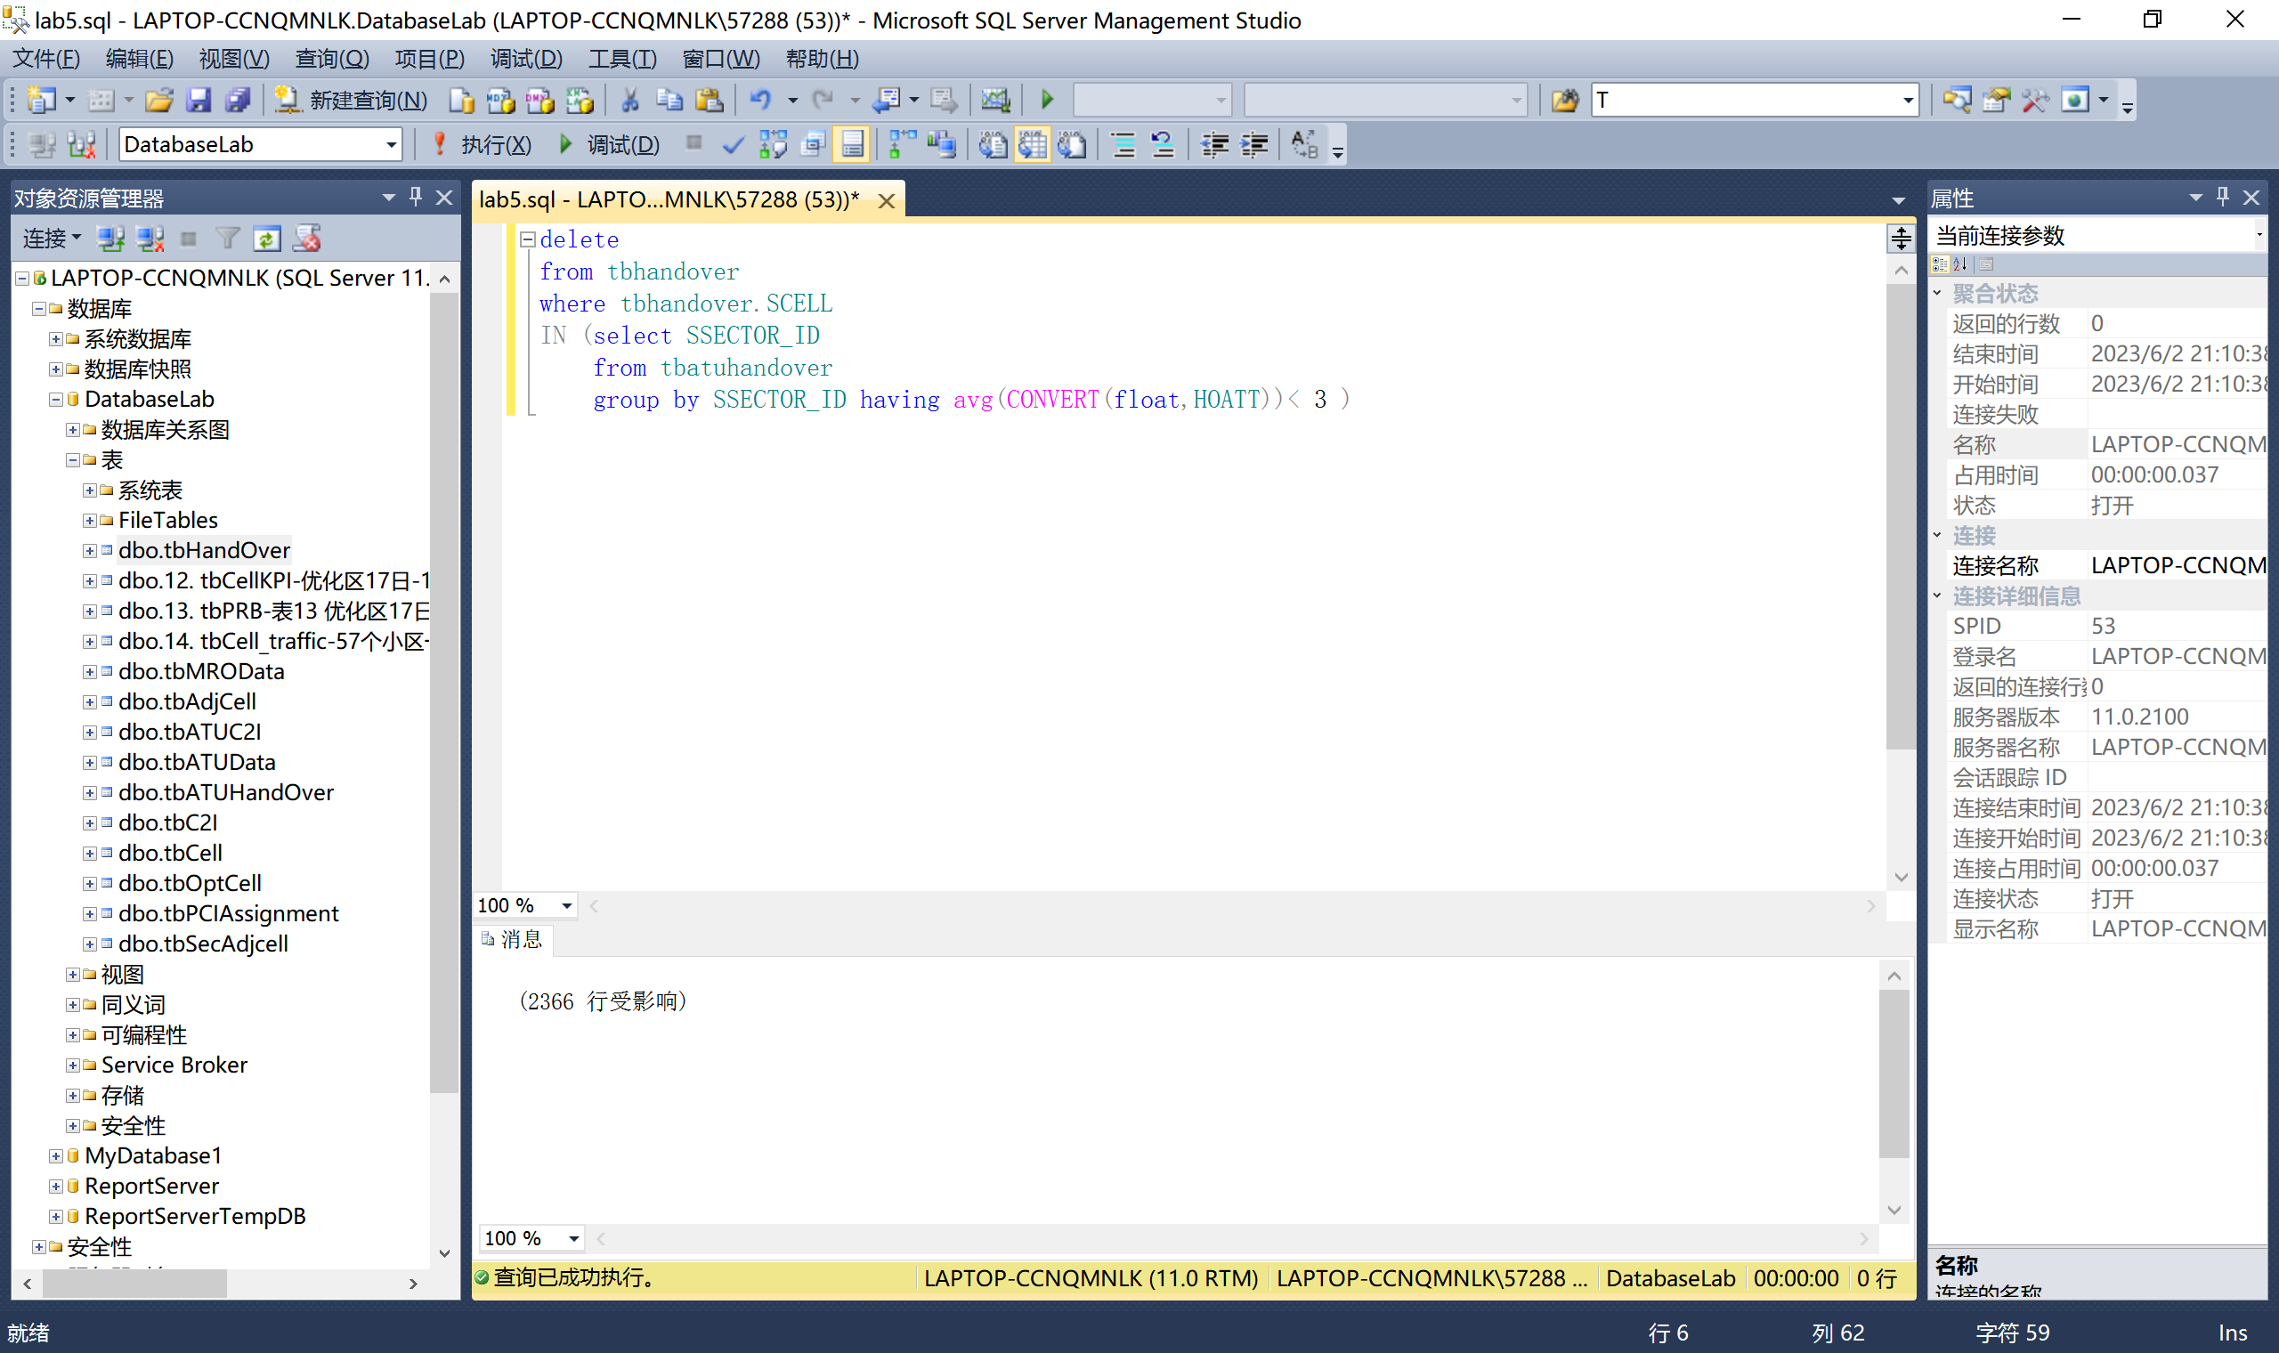

5.8.2 Insertion

向小区/基站工参表中插入一条新信息。

INSERT INTO tbcell

(CITY,SECTOR_ID,SECTOR_NAME,

ENODEBID,ENODEB_NAME,EARFCN,

PCI,PSS,SSS,TAC,VENDOR,LONGITUDE,

LATITUDE,STYLE,AZIMUTH,HEIGHT,

ELECTTILT,MECHTILT,TOTLETILT )

VALUES (

'beiyou',

'123456-1',

'beiyou-HLHF-1',

'123456',

'beiyou-HLHF',

'38400',

'20',

'20',

'20',

'12345',

'北邮',

'111.1111',

'11.111',

'宏站',

'10',

'10',

'1',

'1',

'1')

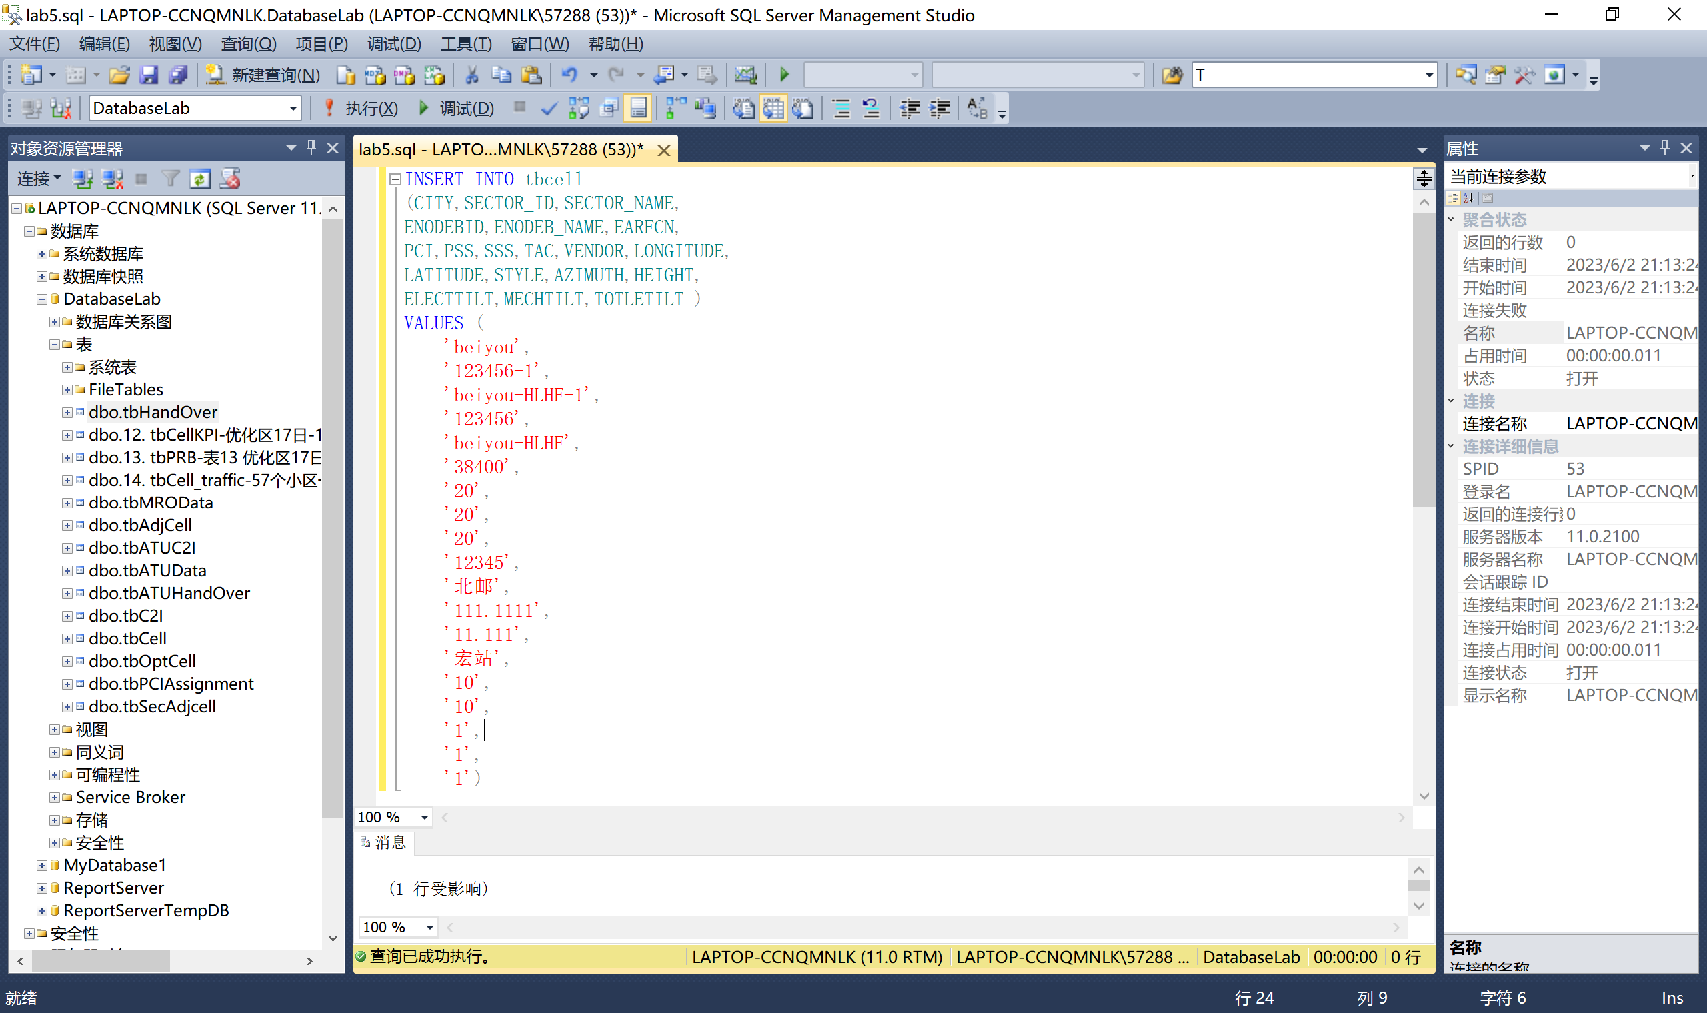

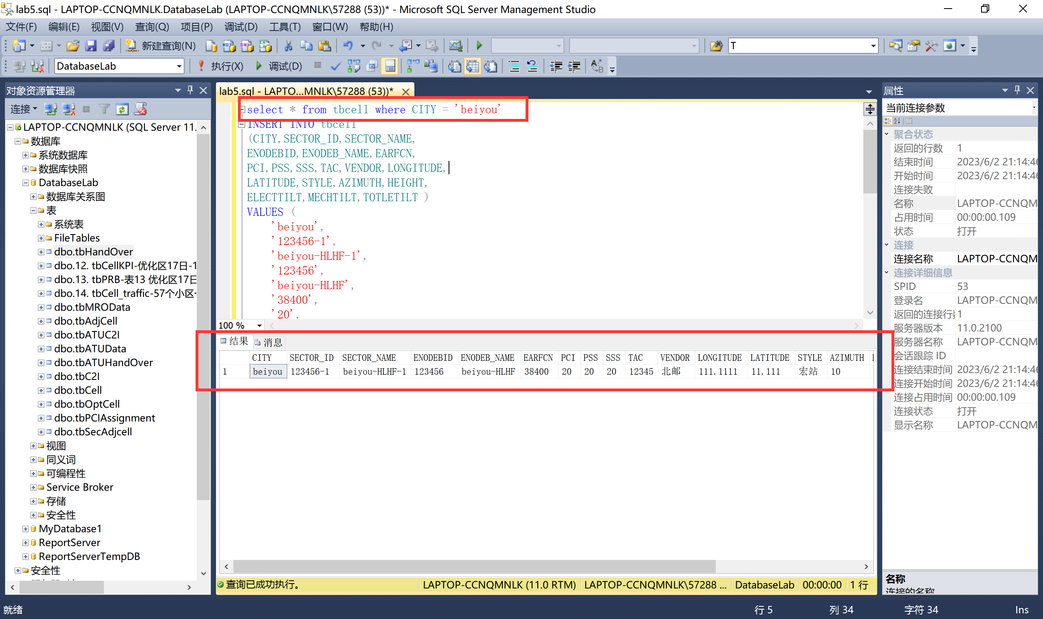

5.8.3 Updates

将优化小区/保护带小区表中，小区ID为“246506-3”的小区的小区类型改为“优化区”。

update tboptcell

set CELL_TYPE = '优化区'

where SECTOR_ID = '246506-3'

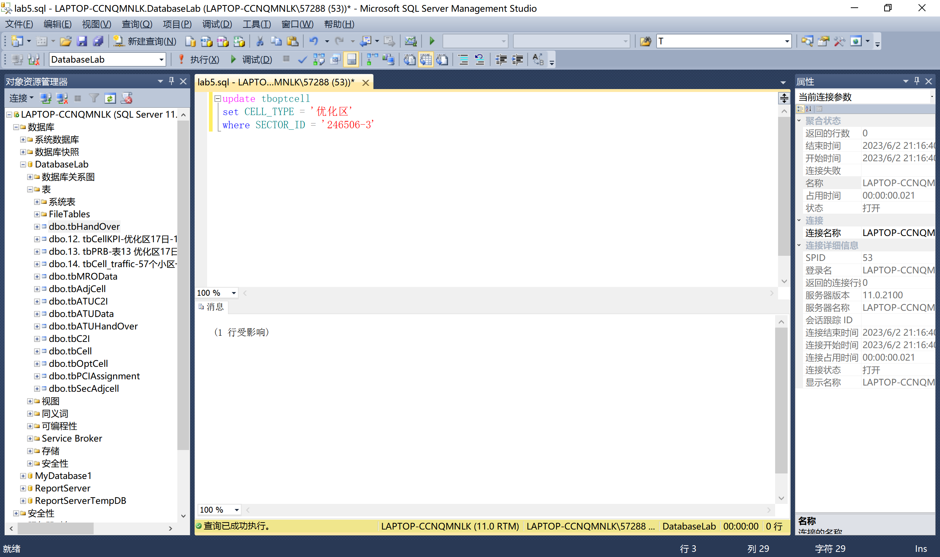

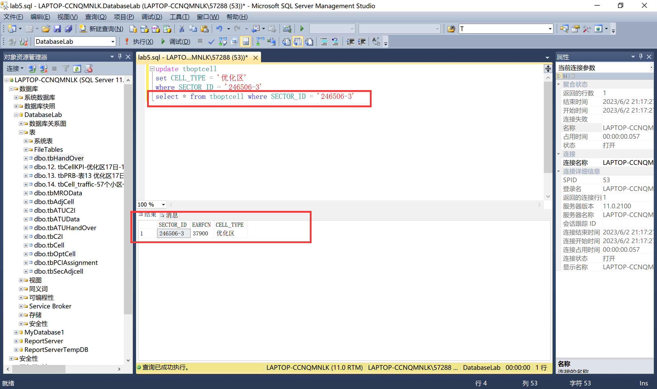

用小区PCI优化调整结果表中“优化调整后的本小区PCI值”，替换小区/基站工参表中小区的“物理小区标识”。

update tbcell

set PCI =( select PCI

from tbpciassignment as tb1

where tbcell.SECTOR_ID = tb1.SECTOR_ID );

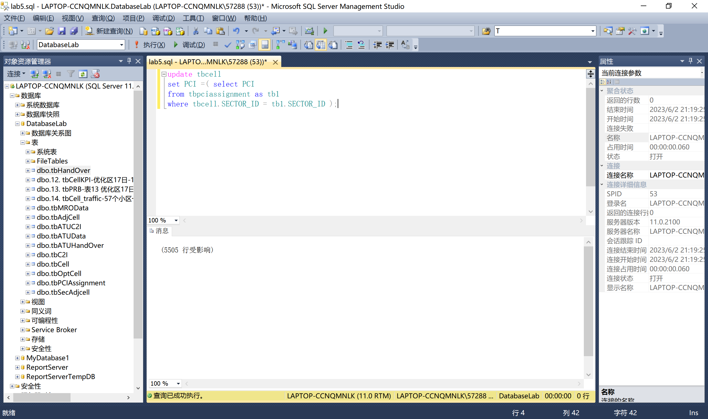

针对路测ATU C2I干扰矩阵表表，使用case语句作出如下修改：如果主小区与干扰小区为同站小区且干扰强度排序不小于1，则干扰强度排序减1；如果主小区与干扰小区不为同站，干扰强度排序加1。

update tbATUC2I

set RANK =(

case when COSITE=1 and RANK >=1 then rank-1

when COSITE=0 then rank+1

end)